A PRAYER FOR THE SOLEMNITY OF MARY AND WORLD DAY OF PEACE, 2022

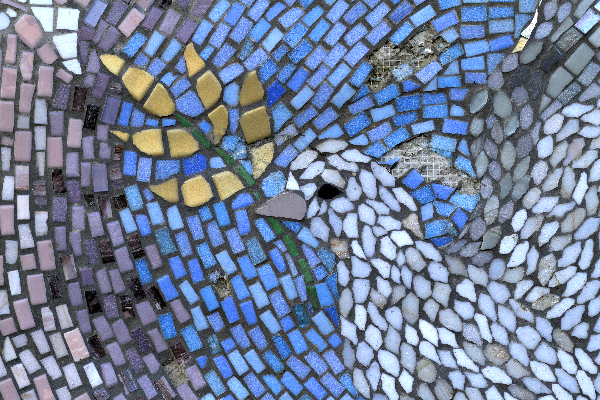
Leader: Every year on January 1, the Solemnity of Mary, our Mother, the Holy Father marks the World Day of Peace with a special message inviting all people to reflect on the important work of building peace. And so, we pray:

Mary, Mother of God, mother of all, who bore and raised the Son of God, who sought to bring peace into the world. You treasured all you saw in your heart, as the fruit of your womb poured out love and mercy to each of us in our own personal way. Pray for us and be with us, that we may remember that we are also treasured in your heart. Help us to always remind others that
they are just as treasured, that the world may know a true and just peace. Amen.

Reading

Reader: An excerpt from Pope Francis’ message on the 2022 World Day of Peace:

“Great social challenges and peace processes necessarily call for dialogue between the keepers of memory – the elderly – and those who move history forward – the young. Each must be willing to make room for others and not to insist on monopolizing the entire scene by pursuing their own immediate interests, as if there were no past and future. The global crisis we are experiencing makes it clear that encounter and dialogue between generations should be the driving force behind a healthy politics, that is not content to manage the present ‘with piecemeal solutions or quick fixes,’ [6] but views itself as an outstanding form of love for others, [7] in the search for shared and sustainable projects for the future.”

Reflection

Leader: The words of Pope Francis remind us that peace is not passive nor simple. It requires creativity, boldness and the vulnerability to meet others intimately in their specific contexts.

- How can you better “meet people where they are at” to facilitate dialogue with those in your community?
- Where might patience or creativity help you in renewing paths to peace?
- What practical or concrete steps can you take to promote the common good and safeguard creation? (Reflect personally or aloud as appropriate).
Closing Prayer

All: God our great architect and artist,
As we navigate the many barriers to peace in our world, grant us the ability to listen intently as you do to each of us. May our listening bring us into deeper relationship with all people, but especially those who are different than us, those who are older and those who are younger. Indeed, we pray that our cross-generational dialogue might “break up the hard and barren soil of conflict and indifference in order to sow the seeds of a lasting and shared peace.”

Through Christ your son, we pray: AMEN.

