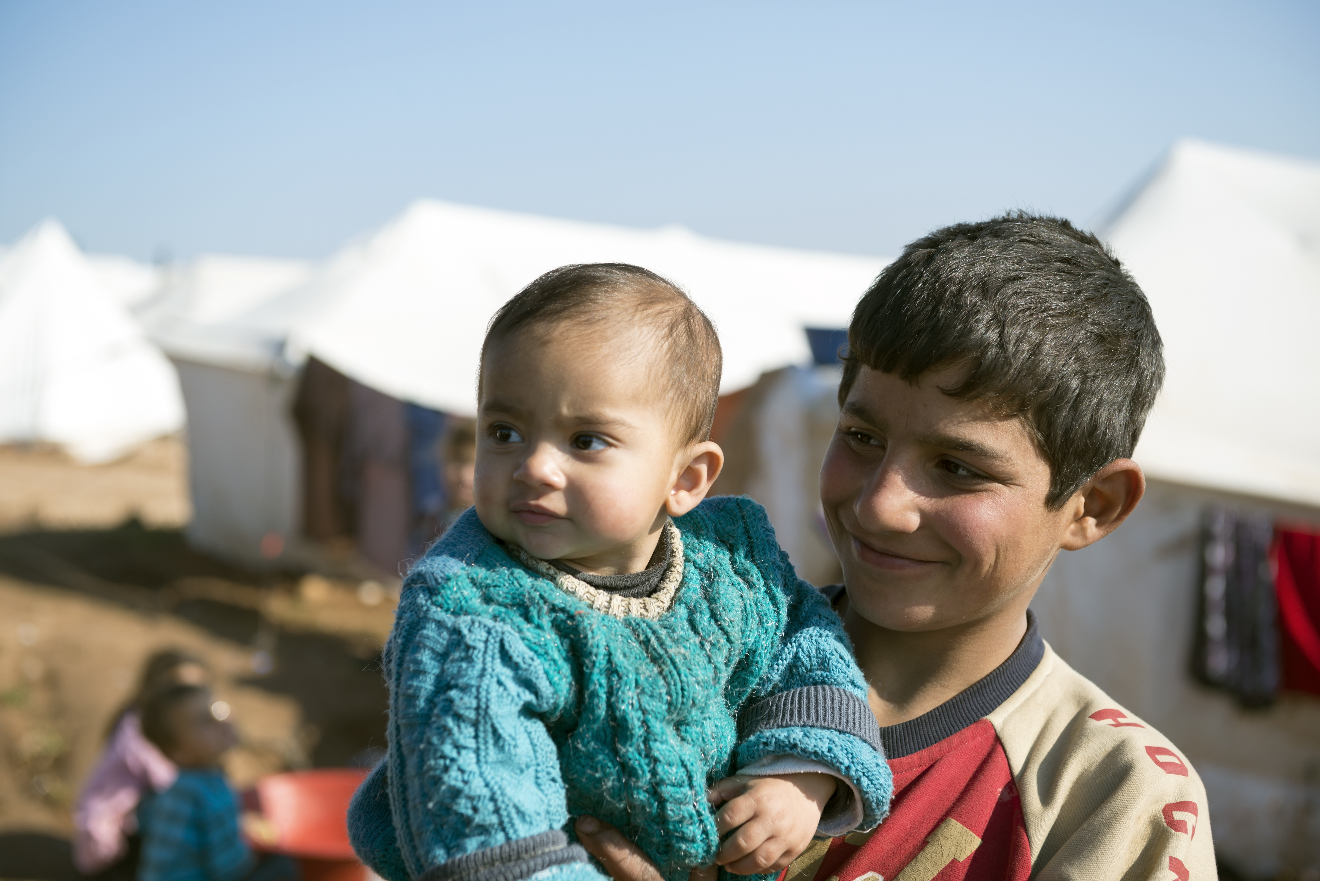
Drawn together by the call to bring those on the margins to the center, each of us stands with the most vulnerable on this World Humanitarian Day.

Some prepare papers for those in need of health insurance, others offer nutrition to children in refugee camps, while a community health worker knocks on doors to understand the needed health resources in a village. We respond to the cry of the lonely, those whose humanity is forgotten, those whose leaders see them as invisible. Let us listen to their voices in restoring humanity.

Let us pray …

God of unity, we ask you to bless the humanitarians who serve others in war zones, among inadequate living conditions, under governments unaware of destructive infrastructures, and even in their own communities. Bring aid to every corner of the earth so that all your children may find themselves able to live full lives; lives that walk with each other as sisters and brothers united with a common humanity. We ask all these things in your name. Amen.

