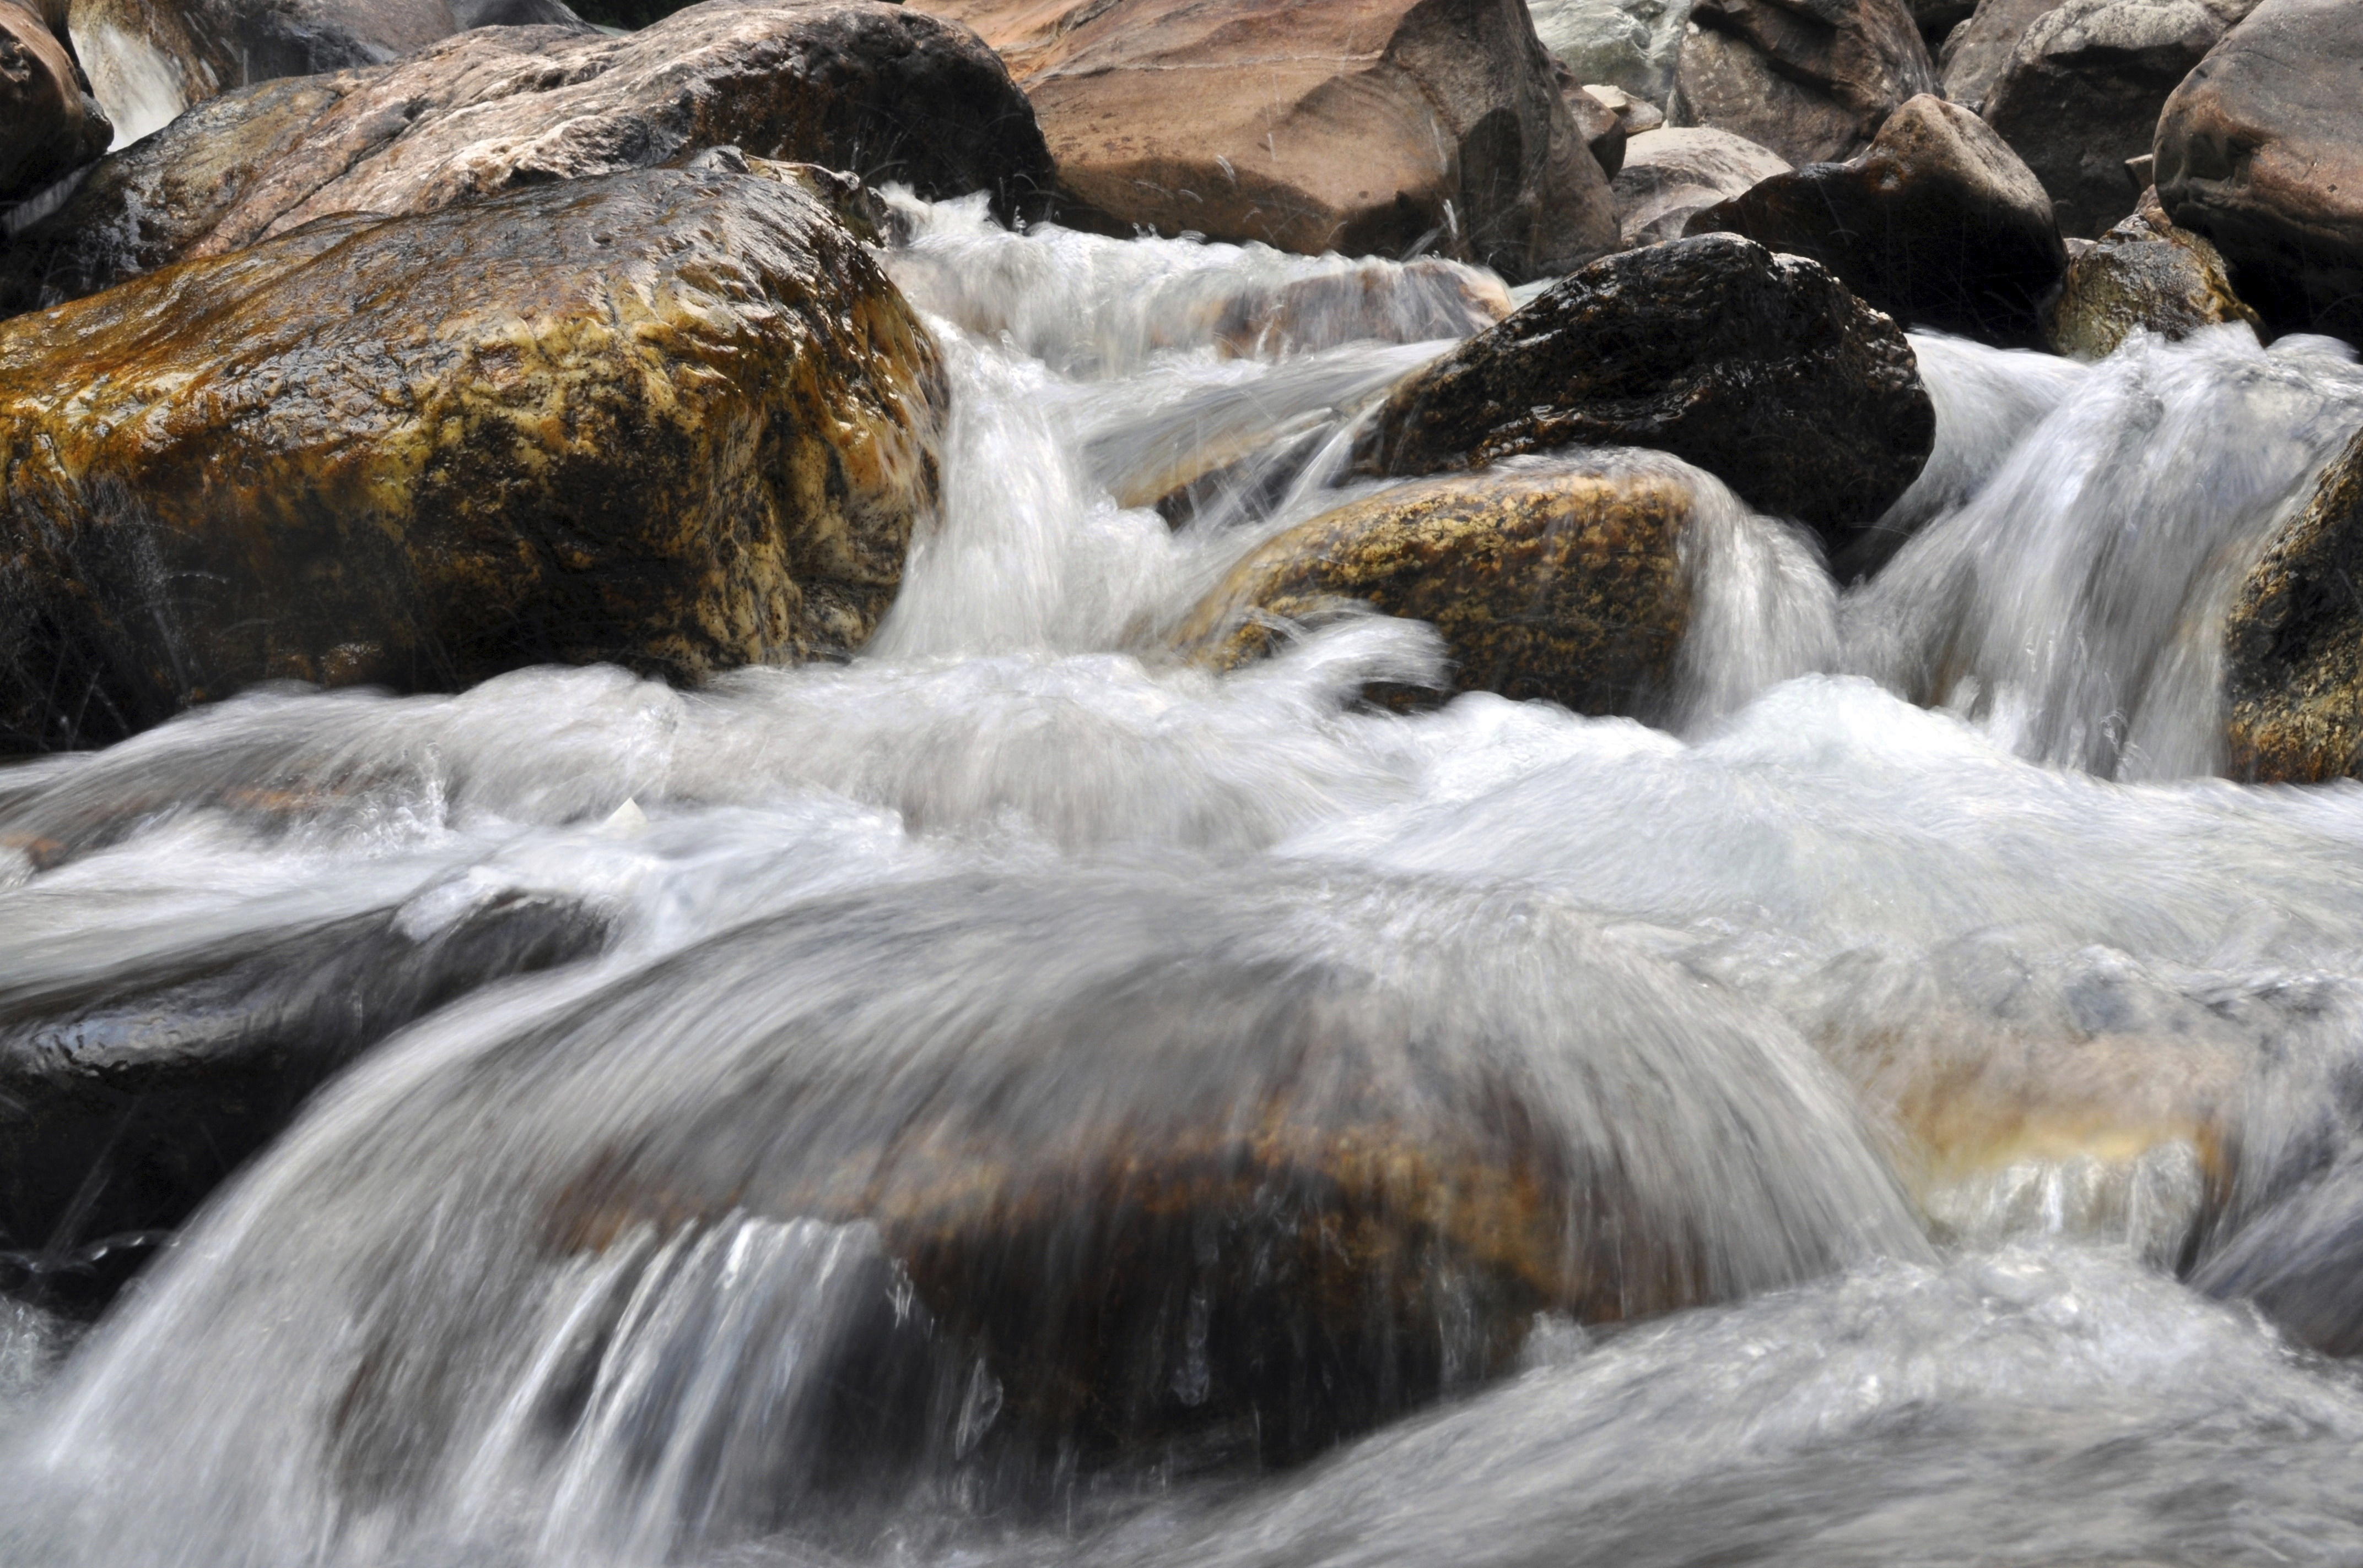
  - Opening Prayer

Loving God, your goodness and beauty are on display in the grandeur, glory and diversity of your creation. We praise and thank you for the wonder of our running streams, vast mountain horizons, light dappled forests and deep blue oceans. May we see them as invitations to raise our eyes, walk into their beauty and meet you in your creation. Amen.

  - Reading

“Everybody needs beauty as well as bread, places to pray in, when nature may heal and give strength to body and soul alike.”
- Jon Muier, founder of the Sierra Club

“The best remedy for those who are afraid, lonely or unhappy is to go outside, somewhere where they can be quite alone with the heavens, nature, and God. Because only then does one feel that all is as it should be and that God wishes to see people happy, admist the simple beauty of nature. As long as this exists, and it certainly always will, I know that then thee will always be comfort for every sorrow, whatever the circumstances may be. And I firmly believe that nature brings solace in all troubles.”
- Ann Frank

  - Reflection Questions
  - Take some time to reflect silently; share with others as time allows.

- How do you bring the beauty of nature into your life?

- How has nature been healing or provide self-care for you?

- How does nature play a role in your health system?

  - Intercessions

May the Sequoia of the redwood forest and the mountains of the Sierras in Peru create in us an ability to stand tall in the face of injustice.

Come Holy Spirit fill us with the fires of your love.

May the calm and serenity of a glowing orange sunrise and sunset distill the fear that we are never alone in our vocation.

Come Holy Spirit fill us with the fires of your love.

May the early morning sound of birds inspire us to defend the nature in our neighborhoods, cities and world from forces only concerned with profit and market share.

Come Holy Spirit fill us with the fires of your love.

May we work to create spaces in our health systems to fill our patient’s hearts with the expanse of nature and the wonders of creation.

Come Holy Spirit fill us with the fires of your love.

  - Closing Prayer

God of all the earth, we thank you for the many plants and bodies of water that bring about the fullness of life. We humbly ask you to instill in us a reverence, attention and devotion to care for the planet. We ask all of this in your name. Amen.

