Opening Prayer
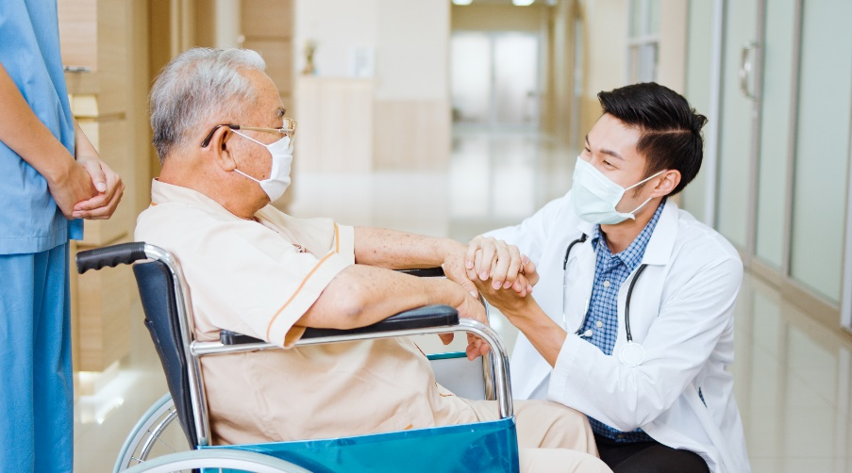
As we gather to remember and pray for all those who are sick in this world, we call to mind our mission as men and women who have committed our varied gifts and talents to helping our brothers and sisters who suffer all forms of illness. Let us not forget the many steps along the way to healing. Let us be gentle with ourselves when we too find that we have become ill. Amen.

Reading
Reader: An excerpt from Pope Francis’ 2022 World Day of the Sick message.

“Jesus’ invitation to be merciful like the Father has particular significance for healthcare workers. I think of all those physicians, nurses, laboratory technicians, the support staff and the caretakers of the sick, as well as the numerous volunteers who donate their precious time to assist those who suffer. Dear healthcare workers, your service alongside the sick, carried out with love and competence, transcends the bounds of your profession and becomes a mission. Your hands, which touch the suffering flesh of Christ, can be a sign of the merciful hands of the Father. […]

Patients are always more important than their diseases, and for this reason, no therapeutic approach can prescind from listening to the patient, his or her history, anxieties and fears. Even when healing is not possible, care can always be given. It is always possible to console, it is always possible to make people sense a closeness that is more interested in the person than in his or her pathology.”

Intercessory Prayer
Leader: Oh God, you have always cared for the sick in a special way, wanting your children to be healed in both body and soul. With Pope Francis, we pray in special gratitude for those health care workers who continue to be signs of the merciful hands of God, offering care and comfort even as they perhaps struggle themselves. As we remember now all the ways you have come to heal the sick, we pray together: Oh God, heal all who are sick in body and soul.

Reader: For I will restore health to you, and your wounds I will heal, declares the Lord, because they have called you an outcast. (Jer. 30:17)
All: Oh God, heal all who are sick in body and soul.

Reader: The Lord sustains him on his sickbed; in his illness you restore him to full health. (Psalm 41:3)
All: Oh God, heal all who are sick in body and soul.

Reader: All who had people sick with various diseases brought them to [Jesus]. He laid his hands on each of them and cured them. (Lk 4:40)
All: Oh God, heal all who are sick in body and soul.

Reader: Whatever town you enter and they welcome you, eat what is set before you, cure the sick in it and say to them, ‘The kingdom of God is at hand for you.’ (Lk 10:8-9)
All: Oh God, heal all who are sick in body and soul.

Closing Prayer
Leader: Hear our prayer, Oh God, and heal the many illnesses that afflict us in body, mind and soul. Bring comfort to those who suffer. Bring consolation to those who despair. Bring strength to those of us who walk with the sick. Bring hope to all for whom the path to healing is long or may not end. Let us never forget your special care for the sick, that they may also know they are precious and loved. Amen.

