Opening Prayer
God of all peace and consolation, you created the heavens and earth to be places of peace for your people. Forgive us for the ways we have disrupted the peace you intend; give us grace to be agents of peace going forward.

Reading 1 - John 14:26-28
The Advocate, the Holy Spirit, whom the Father will send in my name, will teach you everything, and remind you of all that I have said to you. Peace I leave with you; my peace I give to you. I do not give to you as the world gives. Do not let your hearts be troubled, and do not let them be afraid.

Reading 2 - James 3:17-18
The wisdom from above is first pure, then peaceable, gentle, willing to yield, full of mercy and good fruits, without a trace of partiality or hypocrisy. And a harvest of righteousness is sown in peace for those who make peace.

Reflection – Pope Francis, “Good Politics is at the Service of Peace”

In sending his disciples forth on mission, Jesus told them: “Whatever house you enter, first say, ‘Peace be to this house!’ And if a son of peace is there, your peace shall rest upon him; but if not, it shall return to you” (Luke 10:5-6).

Bringing peace is central to the mission of Christ’s disciples. That peace is offered to all those men and women who long for peace amid the tragedies and violence that mark human history. The “house” of which Jesus speaks is every family, community, country and continent, in all their diversity and history. It is first and foremost each individual person, without distinction or discrimination. But it is also our “common home”: the world in which God has placed us and which we are called to care for and cultivate.
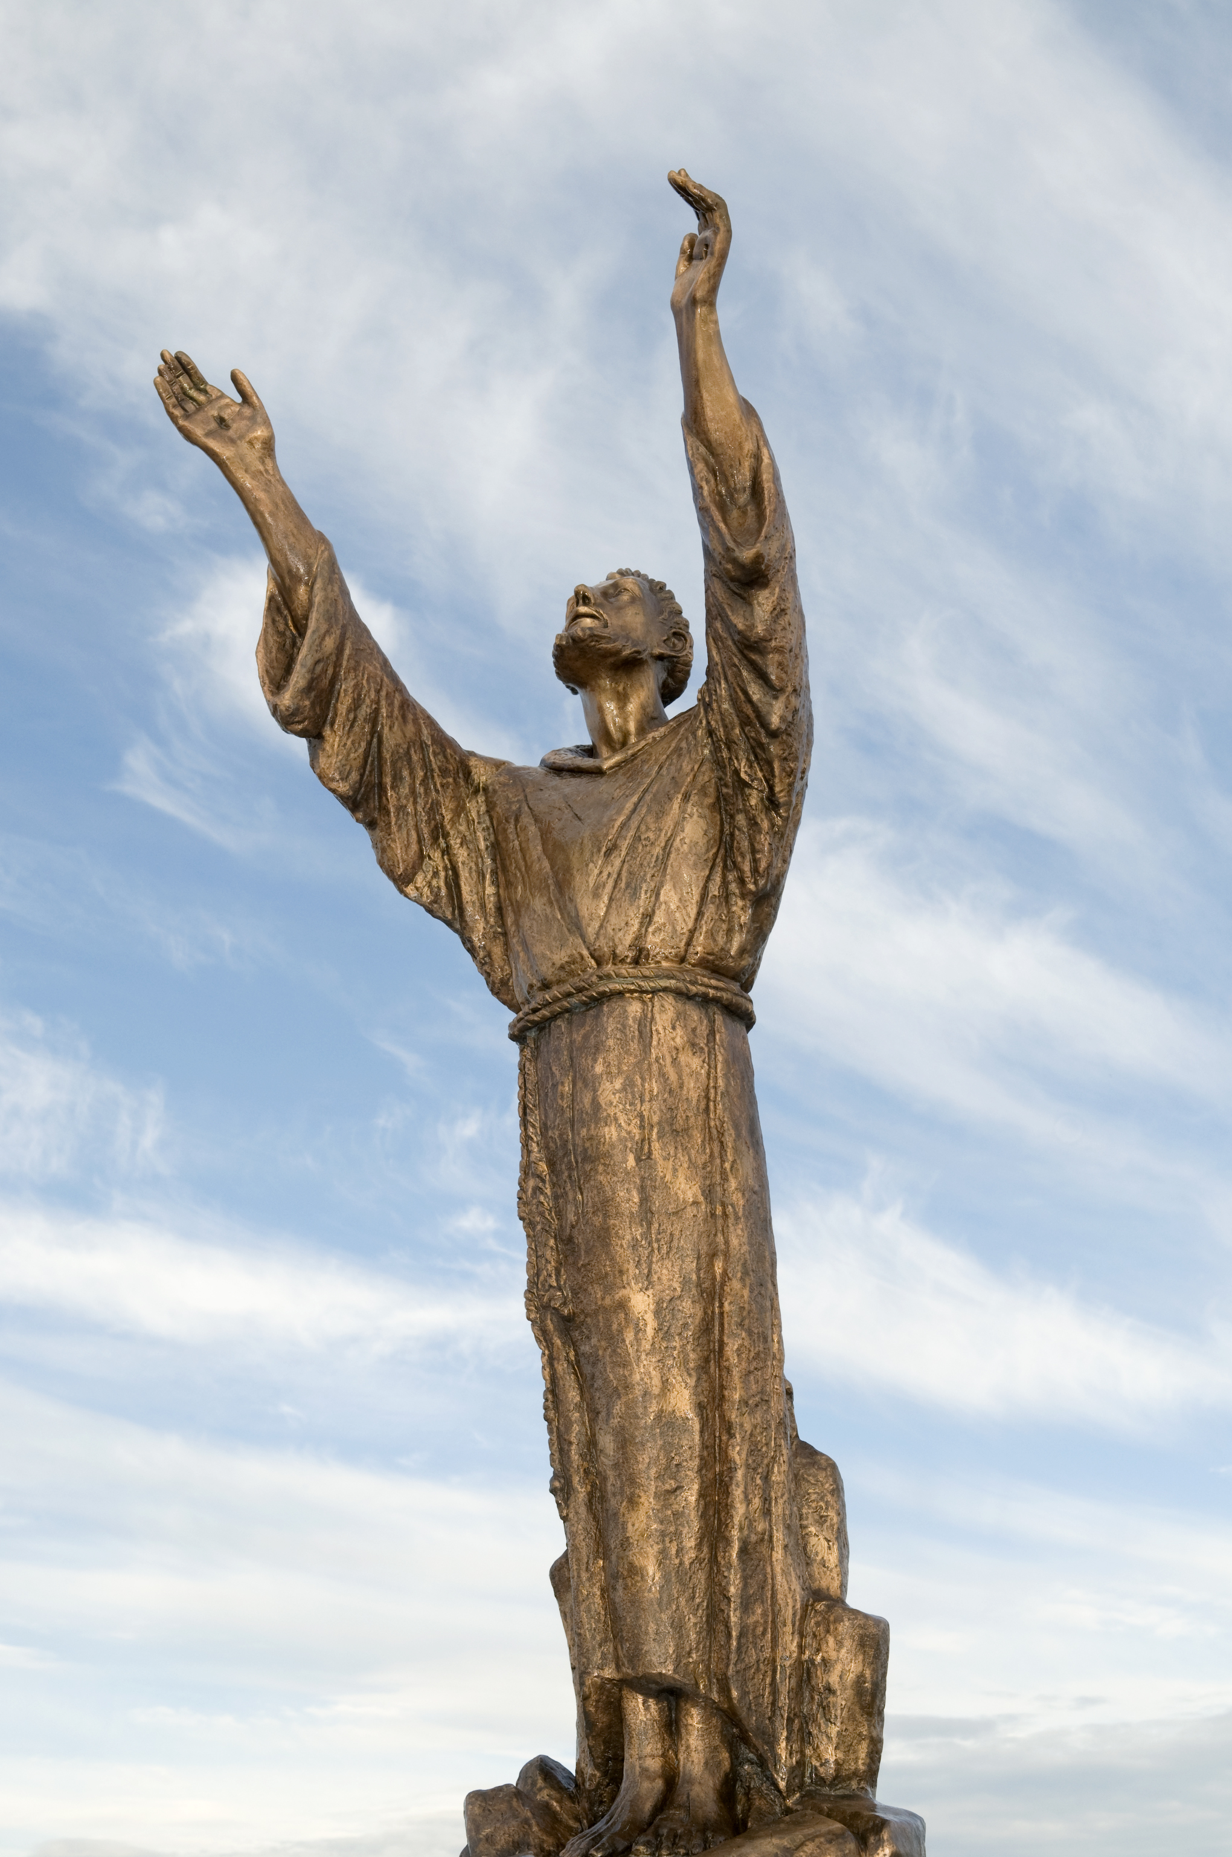
Closing Prayer (Prayer from St. Francis Assisi):

All Lord, make me an instrument of your peace.

Women Where there is hatred, let me sow charity.
Men Where there is injury, let me pardon.

Women Where there is error, let me sow truth.
Men Where there is darkness, let me spread light.

Women Where there is despair, let me sow hope.
Men Where there is sadness, let me spread joy.

All O, Divine Master, Grant that we may not so much seek to be consoled as to console. For it is in giving that we receive; and it is in dying to ourselves that we are born to eternal life. Amen.

