Hear the words of Dr. Martin Luther King Jr.’s sermon given at Montgomery’s Dexter Avenue Baptist Church in 1957. May these words inspire us to love the image of God in those before us today, and every day:

“Even the nation that hates you most has some good in it; even the race that hates you most has some good in it. And when you come to the point that you look in the face of every man and see deep down within him what religion calls ‘the image of God’, you begin to love him in spite of [everything]. No matter what he does, you see God’s image there. There is an element of goodness that he can never sluff off… Another way that you love your enemy is this: when the opportunity presents itself for you to defeat your enemy, that is the time which you must not do it… When you rise to the level of love, of its great beauty and power, you seek only to defeat evil systems. Individuals who happen to be caught up in that system, you love, but you seek to defeat the system… Hate for hate only intensifies the existence of hate and evil in the universe. If I hit you and you hit me and I hit you back and you hit me back and so on, you see, that goes on ad infinitum. It just never ends. Somewhere somebody must have a little sense, and that’s the strong person. The strong person is the person who can cut off the chain of hate, the chain of evil… Somebody must have religion enough and morality enough to cut it off and inject within the very structure of the universe that strong and powerful element of love.”

Pause for a minute of silence. Then allow the lyrics of the song to move you to prayer.

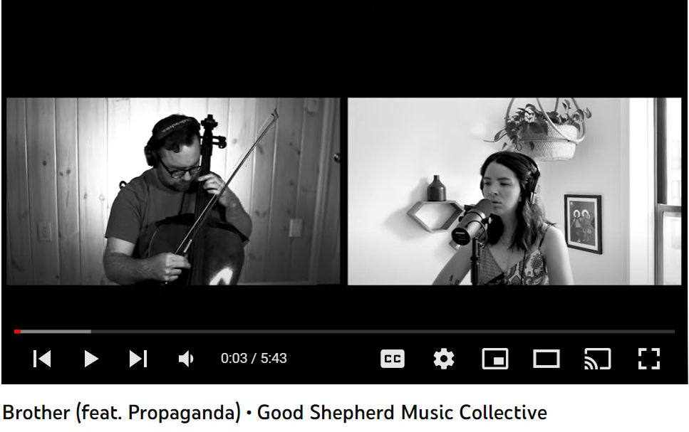

Prayer
Oh God who made us in Your image,
Give us Your eyes that we might see You in all people – especially those not like us.
Give us Your ears that we might respond to those around us in love – especially when it
costs us be silent or demands that we speak out for the sake of others.
Give us Your heart and move it to act with radical love and compassion – especially when we
are inclined to do nothing or to do what is beyond ours to do.
We ask this for the sake of Your prayer: that we may be one in You. Amen.

