Song Suggestions: The Summons, All Are Welcome, The Servant Song

Call to Prayer
Do not neglect to show hospitality to strangers, for by this some have entertained angels without knowing it. (Hebrews 13:2)

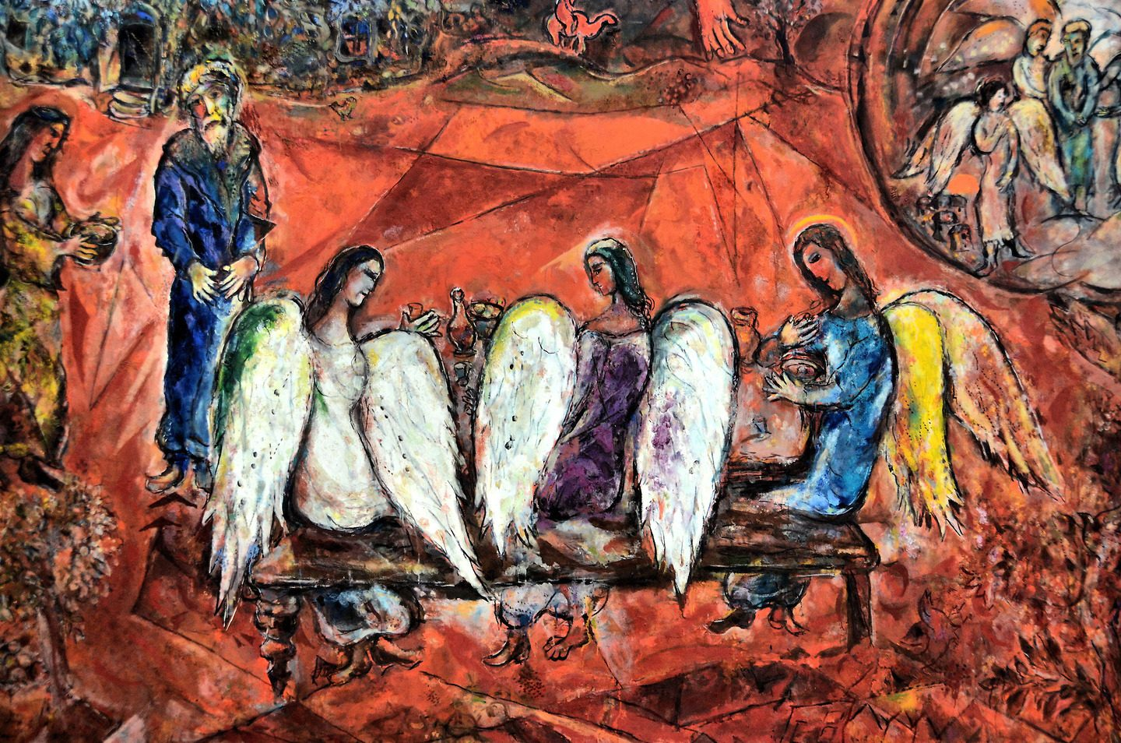
Reading: Abraham at Mamre
(Genesis 18:1-8)
The Lord appeared to Abraham by the oaks of Mamre, as he sat at the entrance of his tent in the heat of the day. He looked up and saw three men standing near him. When he saw them, he ran from the tent entrance to meet them, and bowed down to the ground. He said, “My lord, if I find favor with you, do not pass by your servant. Let a little water be brought, and wash your feet, and rest yourselves under the tree. Let me bring a little bread, that you may refresh yourselves, and after that you may pass on—since you have come to your servant.” So they said, “Do as you have said.” And Abraham hastened into the tent to Sarah, and said, “Make ready quickly three measures of choice flour, knead it, and make cakes.” Abraham ran to the herd, and took a calf, tender and good, and gave it to the servant, who hastened to prepare it. Then he took curds and milk and the calf that he had prepared, and set it before them; and he stood by them under the tree while they ate.

Shared Reflection
Consider together and share your reflections on the following questions

- What is most meaningful to you about your work?

- How do welcome and hospitality play a role in your ministry?

(over)
Closing Prayer (All pray together)

Holy Spirit, you have called us to the work of spiritual care and through it, we tend to your people. Descend upon us that we may unite our talents with your gifts for the good of those we serve.

Bless us with wisdom and understanding to recognize the deep needs of those we care for and find creative ways to meet their needs.

Bless is with your wise counsel to walk together with others and uncover your plans for our good. Bless us with the courage to speak hope into darkness.

Bless us with a piety that recognizes we are your people, united with all in distress and need. Bless us with awe and wonder at your loving graciousness, ever-present to us in our work.

Sustainer and Comforters of the world, mold us into your image that we may be welcome refuge for all we meet. AMEN.

