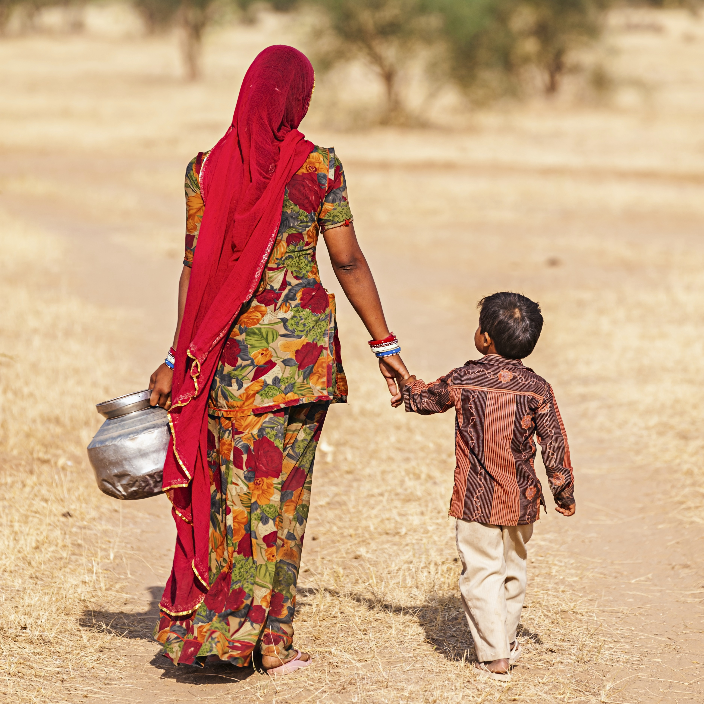
In his encyclical, Laudato Si, Pope Francis writes, “access to safe drinkable water is a basic and universal human right, since it is essential to human survival and, as such, is a condition for the exercise of other human rights. Our world has a grave social debt towards the poor who lack access to drinking water, because they are denied the right to a life consistent with their inalienable dignity.”

Today, on World Water Day, let us lift our voices in prayer for all persons who are on the margins, especially those who do not have access to safe water sources.

We pray for the 663 million people who lack access to safe water.
Plant our hearts near streams of compassion.

We pray for the women and children who spend hours each day walking to collect water.
Plant our hearts near streams of compassion.

We pray for the 800,000 deaths per year attributable to unsafe water supply, poor sanitation and hygiene.
Plant our hearts near streams of compassion.

We pray for a reduction in the 38 billion plastic water bottles that end up in landfills every year.
Plant our hearts near streams of compassion.

We pray for greater accountability and transparency when public water systems are threatened.
Plant our hearts near streams of compassion.

Good and gracious God, we pray for humility to see all the ways we take water for granted. Send Your Spirit to change the hearts of those who use water to create strife and conflict. Have mercy on those who are sick or in need because they cannot access safe water. We are thankful for Your gift of water seen in the beauty of waterfalls, placid lakes, rivers that move people and commerce, oceans full of amazing creatures. Give us guidance on how to be better stewards of a finite resource. We ask all of this in Your name. Amen.

