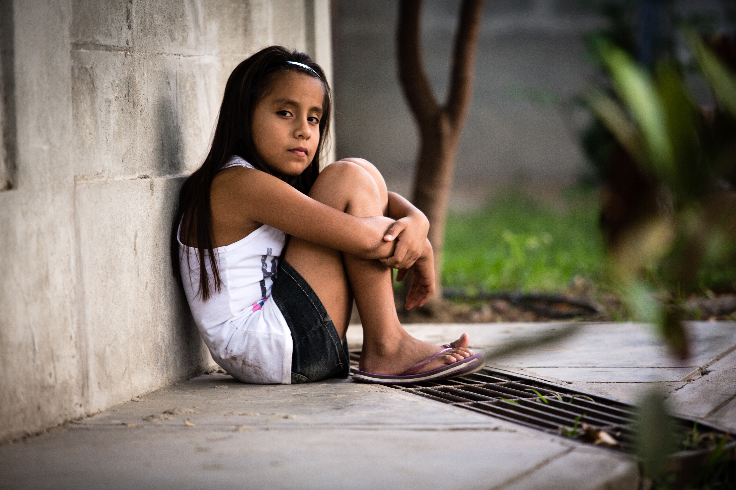
International Day for the Eradication of Poverty
Observation of the International Day for the Eradication of Poverty began in 1993 when the United Nations General Assembly designated a day to promote awareness of the need to eradicate poverty and destitution in all countries. It calls us both to greater awareness of this plague in our world and to concrete actions for poverty’s relief.

Reading 1:
“The times talk to us of so much poverty in the world and this is a scandal. Poverty in the world is a scandal. In a world where there is so much wealth, so many resources to feed everyone, it is unfathomable that there are so many hungry children, that there are so many children without an education, so many poor persons. Poverty today is a cry.”
- Pope Francis, Meeting with Students of Jesuit Schools, Q & A, June 2013

Reading 2:
“He sat down opposite the treasury and observed how the crowd put money into the treasury. Many rich people put in large sums. A poor widow also came and put in two small coins worth a few cents. Calling his disciples to himself, he said to them, ’Amen, I say to you, this poor widow put in more than all the other contributors to the treasury. For they have all contributed from their surplus wealth, but she, from her poverty, has contributed all she had, her whole livelihood.’” (Mark 12: 41-44)

Reflection:
It seems such a huge task, to eradicate poverty. I am but one person. But let me not be overwhelmed. Let me rather be emboldened to play whatever small role I can play and trust that others will do the same.

- What local charity works to eradicate poverty in my community? How can my coworkers and I support them?

- How can I change my consumption of goods to protect those who are impoverished by an unjust economic system?
(over)
- What change can I ask of my elected officials to help those in poverty around the world?

- When speaking with God, what can I ask for those whose lives are always on the edge because they lack the resources to live in greater security?

Prayer:
Good and Gracious God, we ask Your blessing on the cry of the hungry, upon those who have gone without for too long. We ask for Your mediation with those who could bear to share their wealth and resources with others. We are resolved to tackle this enormous issue in collaboration with those living in poverty, but we can only do so with Your help. We ask for Your Wisdom and Guidance to remove this scandal from our world, which you have blessed with such abundance.

Amen.

