“The aim of this instruction is love from a pure heart, a good conscience, and a sincere faith.” (1 Tim 1:5)

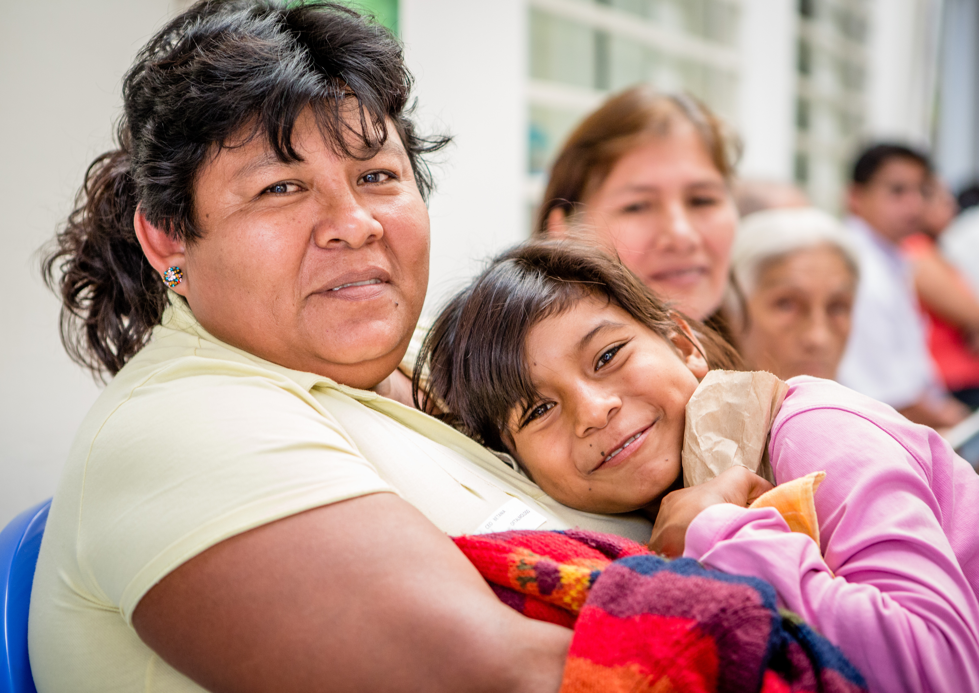
Leader: As we enter into this work of promoting health around the world, let us call to mind that we bring all that we are, both our gifts and our struggles. We offer it all to God, trusting that God will transform it so that the people we seek to serve may be filled with life abundant …

Side A: We bring our expertise, our resources and our experience in building health. May we also consider the expertise, resources and experience of our global partners.

Side B: We bring our hopes, our desires and our goals for improving lives. May we also consider the hopes, desires and goals of those we seek to serve.

Side A: We bring our struggles, our fears and our failings that will not fade away. May we be patient with the struggles, fears and failings of those with whom we work.

Side B: We bring the faces of the women, men and children we hope benefit from our work. May we be attentive to the faces of those we have yet to even imagine.

Side A: We bring the needs we see in so many corners of the world. May we also see with the eyes of those who live in those corners every day.

Side B: We bring our faith and trust in God who animates all we do. May we find consolation in the faith and trust revealed by the communities we serve.
(over)
Leader: Let us not be overwhelmed by the task before us. There are too many people of good will for any to be anxious. Instead, let us lean on one another. Let us look toward God, who gathers all nations into one. Let us approach this work with the humility and faith that the gifts and talents we bring are exactly what is needed at this moment.

Let us pray together the words of the Psalmist …

All: Fill us at daybreak with your love,
that all our days we may sing for joy.
Make us glad as many days as you humbled us,
For as many years as we have seen trouble.
Show your deeds to your servants,
Your glory to their children.
May the favor of the Lord our God be ours.
Prosper the work of our hands!
Prosper the work of our hands!

Amen.

