A Prayer and Reflection for the Feast of our Lady of Guadalupe

Our Lady of Guadalupe
The feast of our Lady of Guadalupe is celebrated on December 12th and is a Holy Day of Obligation in Mexico. For more information on the story of Our Lady of Guadalupe and the life of Saint Juan Diego, visit www.franciscanmedia.org/our-lady-of-guadalupe/.

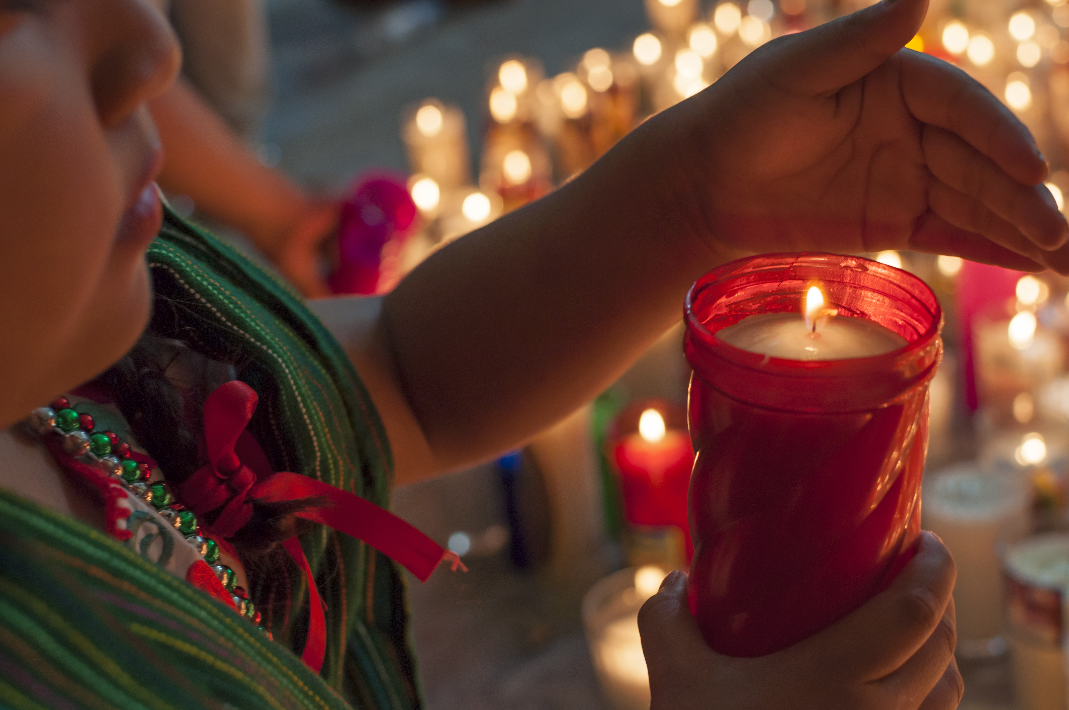
A Prayer and Reflection
In the light of a December morning in rural Mexico, a humble farmer walks to mass and is astonished when he comes face to face with a radiant apparition of Mary as a pregnant young woman in native clothes. Thus begins a relationship between Our Lady of Guadalupe and Juan Diego that will change the church. When all is said and done, a church will be built, roses will bloom in the snow, a miraculous image will appear on an ordinary cloak and a man will be healed of a life-threatening fever.

Patroness of the Americas, Our Lady of Guadalupe reminds us of God’s love for those who are lowly in this world, particularly as Jesus was born lowly and poor in a stable. As we pray with the example of Our Lady of Guadalupe today, how might we be called to be in solidarity with those who are poor and vulnerable, especially as we anticipate the birth of Jesus?

God of all peoples, we thank and bless you for the protection and love of Our Lady of Guadalupe. In her we see your affection for all peoples and feel your desire to be near to your people. Mother of the Americas, guide and comfort us with your loving presence as we, like you, seek to say yes to God’s call in our lives. Intercede on behalf of those who are ill. Inspire in us the faithfulness of Juan Diego as we seek to do the will of your son in the world. Amen.

