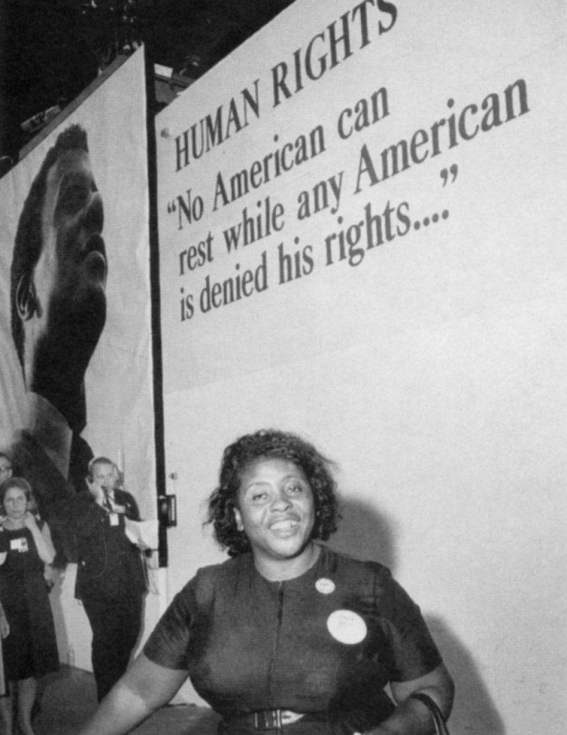
IT'S IN YOUR HANDS
REFLECTION

Leader Fannie Lou Hamer was a powerful civil rights leader. She consistently fought for women's rights, economic justice, and black empowerment, and her deep influence among a generation of Black activists cannot be overemphasized.
In a 1971 speech, Ms. Hamer shared the following parable:
Reader 1 I would like to tell you in closing a story of an old man. This old man was very wise, and he could answer questions that were almost impossible for people to answer.
So some people went to him one day, two young people, and said, "We're going to trick this guy today. We're going to catch a bird, and we're going to carry it to this old man, and we're going to ask him, 'This that we hold in our hands today, is it alive or is it dead?' If he says 'Dead,' we're going to turn it loose and let it fly, but if he says, 'Alive,' we're going to crush it."
So they walked up to this old man, and they said, "This that we hold in our hands today, is it alive or is it dead?" He looked at the young people and he smiled. And he said, "It's in your hands."
Leader God of justice and mercy, there is much that is out of our hands; much that we cannot control. And yet, some changes are ours to make. The work of anti-racism and racial justice is ours to do, it is in our hands. Pray with us, Move us to change, O God.
Reader 2 For the courage to look honestly at the institutionalized racism of our society and at our own inherited biases. We pray:
All Move us to change, O God
Reader 3 For the ways in which racism diminishes the humanity of each person especially those communities who sustained the greatest loss of life from COVID-19 due to health disparities. We pray:
All Move us to change, O God
Reader 4 For deepened listening and stronger relationships within our communities so that our commitments can be resolute, humble and focused on providing care that honors the full human dignity of all people. We pray:
All Move us to change, O God
Leader God of all, You became vulnerable and humble for our sake. Make us willing to be vulnerable and humble for the sake of our brothers and sisters. Give us the fire of Your spirit in building a just society, in Jesus' name. Amen.

Photo copied from https://www.washingtonpost.com/news/retropolis/wp/2017/10/06/civil-rights-crusader-fannie-lou-hamer-defied-men-and-presidents-who-tried-to-silence-her/, where this caption was included: Fannie Lou Hamer walks toward the entrance to the convention hall, where she was finally admitted. (UPI/Bettmann).

