Human Trafficking Prayer

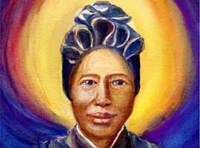
February 8 – International Day of Prayer for Victims of Human Trafficking
February 8th marks the International Day of Prayer for Victims of Human Trafficking. Designated by the Pontifical Council for Justice and Peace and the International Union of Superiors General, the day invites us to advocacy and remembrance for victims and survivors of forced labor and commercial sex trafficking.
The day of prayer and awareness coincides with the feast of St. Josephine Bakhita who herself was kidnapped as a child and sold into slavery. At age 27, having been sold multiple times, St. Josephine was awarded her freedom in an Italian court and became a Canossian Daughter of Charity.
In the company of saints, with the church and all people of goodwill, let us pray for survivors, victims and all people enmeshed in the systems of human trafficking across the world.
- For survivors of slavery, that God guide them to a path down which they might find wholeness and peace. Through the intercession of Saint Josephine Bakhita, patron saint of human trafficking survivors, we pray to the Lord. Lord, hear our prayer.
- For all of those children, women and men currently trapped in situations of slavery that God will help to liberate them from their chains. Through the intercession of Saint Peter Claver, patron saint of slaves, we pray to the Lord. Lord, hear our prayer.

- For all those vulnerable to being trafficked, especially immigrants and refugees, orphans and runaways that God give them safe passage and safe homes. Through the intercession of Saints Frances Xavier Cabrini, Gerolamo
Emiliani and Dymphana, we pray to the Lord. Lord, hear our prayer.

For all people, that we may come to believe in and act upon our unity as one family and devote ourselves to honoring the inherent dignity of each person. Through the intercession of Mary, we pray to the Lord. Lord, hear our prayer.

©The Catholic Health Association of the United States

