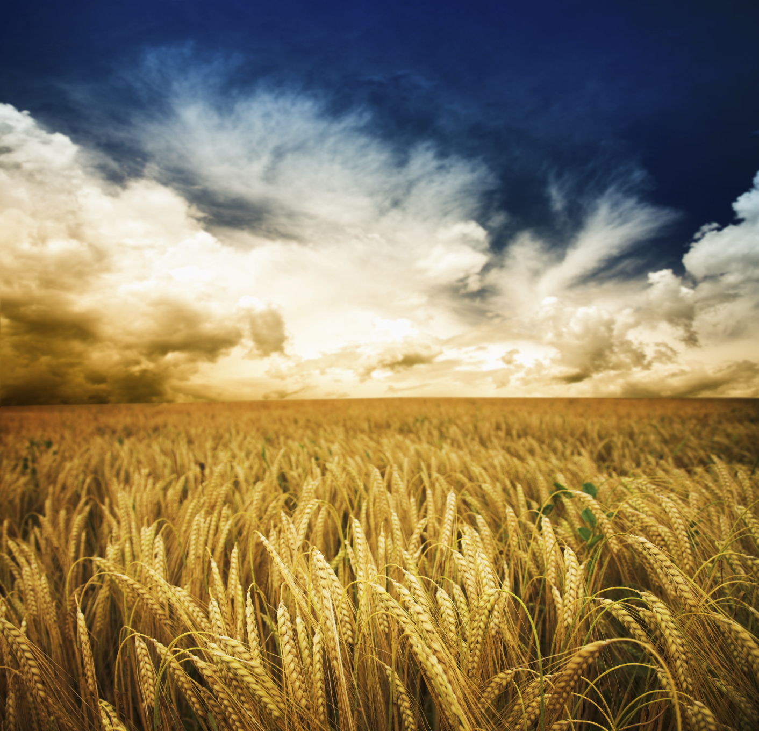
Opening Psalm 34: 6, 15-17

This poor soul cried, and was heard by the Lord,
and was saved from every trouble.
The eyes of the Lord are on the righteous,
and his ears are open to their cry.
The face of the Lord is against evildoers,
to cut off the remembrance of them from the earth.
When the righteous cry for help, the Lord hears,
and rescues them from all their troubles.

Reflection
Scripture promises that the Lord hears and responds to the cries of the poor and will treat those that exploit others accordingly. It can seem that no matter how hard we work to serve and care for those in need, the needs keep compounding.
While the poor have always been made up of those who lacked basic goods due to injury, illness or tragedy, today, many remain poor due to systems of our own creation. In a world where a prolonged illness can be the difference between being able to make ends meet and bankruptcy, ending social inequities that impact health is an imperative. In a world where wages do not meet needs, an extra job may be the difference between a meal and going to bed hungry.
In the Mosaic Law, God instituted what amounted to an odd social program to benefit only the poor. “When you reap the harvest of your land, you shall not reap to the very edges of your field, or gather the gleanings of your harvest. You shall not strip your vineyard bare, or gather the fallen grapes of your vineyard; you shall leave them for the poor and the immigrant: I am the Lord your God” (Lev 19:9-10).
In an economy that is built upon principles of efficiency, this seems unfathomable. Farmers have spent decades developing machinery to avoid problems like this. Yet, God has called us to only harvest the field once. Anything leftover must be left for the poor. While today that may seem like just leaving a pittance, in an era of imperfect harvesting methods, this likely would have left a great deal for the poor.
The Israelite practice of gleaning enforced a social program that focused on the value of the person rather than the financial gain of the industry. The practice stipulated that no judgement should be put on those gleaning, and no person should be turned away. In an effort to eradicate poverty, one of the greatest steps is to help the poor reclaim their human dignity. In doing so, we open our hearts without judgement or reservation to meet the poor in their complexity and inefficiency because they are God’s beloved.
Closing Prayer:
Jesus of Nazareth, Son of God, Son of Poverty,
You are near to those in need and mindful of those on the margins.
We pray for the day all people have what they need to thrive.
We long for the day all people live within flourishing communities.
Make us instruments of abundance, sharing what we have with others,
Opening doors formerly closed and serving you on the margins.
Amen.

