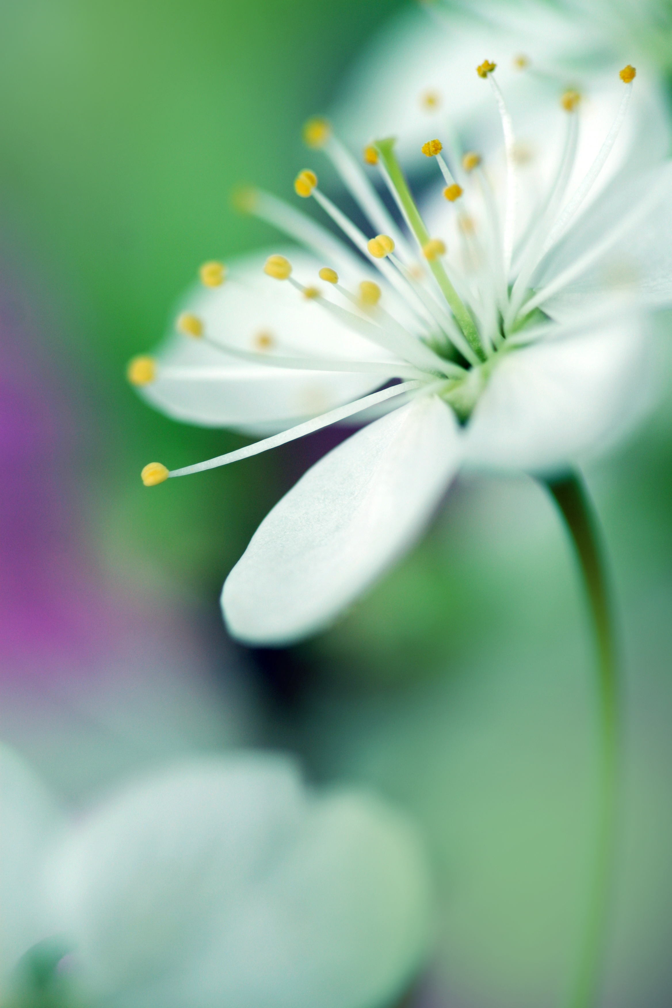
Leader: Let us be still in the presence of God and one another.

[Pause]

The Easter season is the happiest and most joyful season in the life of the Church. The faithful who live in the Northern Hemisphere celebrate the resurrection of Christ amidst the joy and wonder of natural season of spring. It seems the whole creation bears witness to the glory of God’s work and the promise of eternal life.

Trappist monk Thomas Merton reflects, “A tree gives glory to God by being a tree. For in being what God means it to be the tree is obeying Him … The more a tree is like itself, the more it is like Him …

For me, to be a saint means to be myself. Therefore, the problem of sanctity and salvation is, in fact, the problem of finding out who I am and of discovering my true self.”

As we pray, let us remember that the praise God desires is our hearts on fire with love, our service offered to the world and ourselves authentically living as beloved children of God.

[Pause]

Let us pray, praise the Holy One, all you servants of God’s name.

All: Christ, our Redeemer, has risen from the tomb: let us sing a hymn to the Lord, our God. Alleluia.

Side One: All you works of the Lord, bless the Lord.
And you, angels of the Lord, bless the Lord.
To God be highest glory and praise for ever.

Side Two: And you, the holy heavens, bless the Lord.
And you, clouds of the sky, bless the Lord.
And you, all armies of the Lord, bless the Lord.
To God be highest glory and praise for ever.
Side One: And you, sun and moon, bless the Lord.
And you, the stars of the heavens, bless the Lord.
And you, showers and rain, bless the Lord.
To God be highest glory and praise for ever.

Side Two: And you, night-time and day, bless the Lord.
And you, darkness and light, bless the Lord.
And you, lightning and clouds, bless the Lord.
To God be highest glory and praise for ever.

Side One: And you, mountains and hills, bless the Lord.
And you, all plants of the earth, bless the Lord.
And you, fountains and springs, bless the Lord.
To God be highest glory and praise for ever.

Side Two: And you, rivers and seas, bless the Lord.
And you, creatures of the sea, bless the Lord.
And you, every bird in the sky, bless the Lord.
And you, wild beasts and tame, bless the Lord.
To God be highest glory and praise for ever.

Side One: O Israel, bless the Lord, bless the Lord.
And you, children of the Lord, bless God’s name.
And you, beloved of the Lord, bless God’s name.
And you, servants of the Lord, bless God’s name.
To God be highest glory and praise for ever.

Leader: May our authentic living as the people God created us to be and our participation with God to bring beauty, goodness and truth into the world be our true worship this Easter season.

All: Let us praise the Father, the Son and Holy Spirit:
To you be highest glory and praise for ever.
May you be blessed, God, in the heavens.
To you be highest glory and praise for ever.

