The heavens speak of the Creator’s glory and the sky proclaims God’s handwork. (Psalm 19:2)

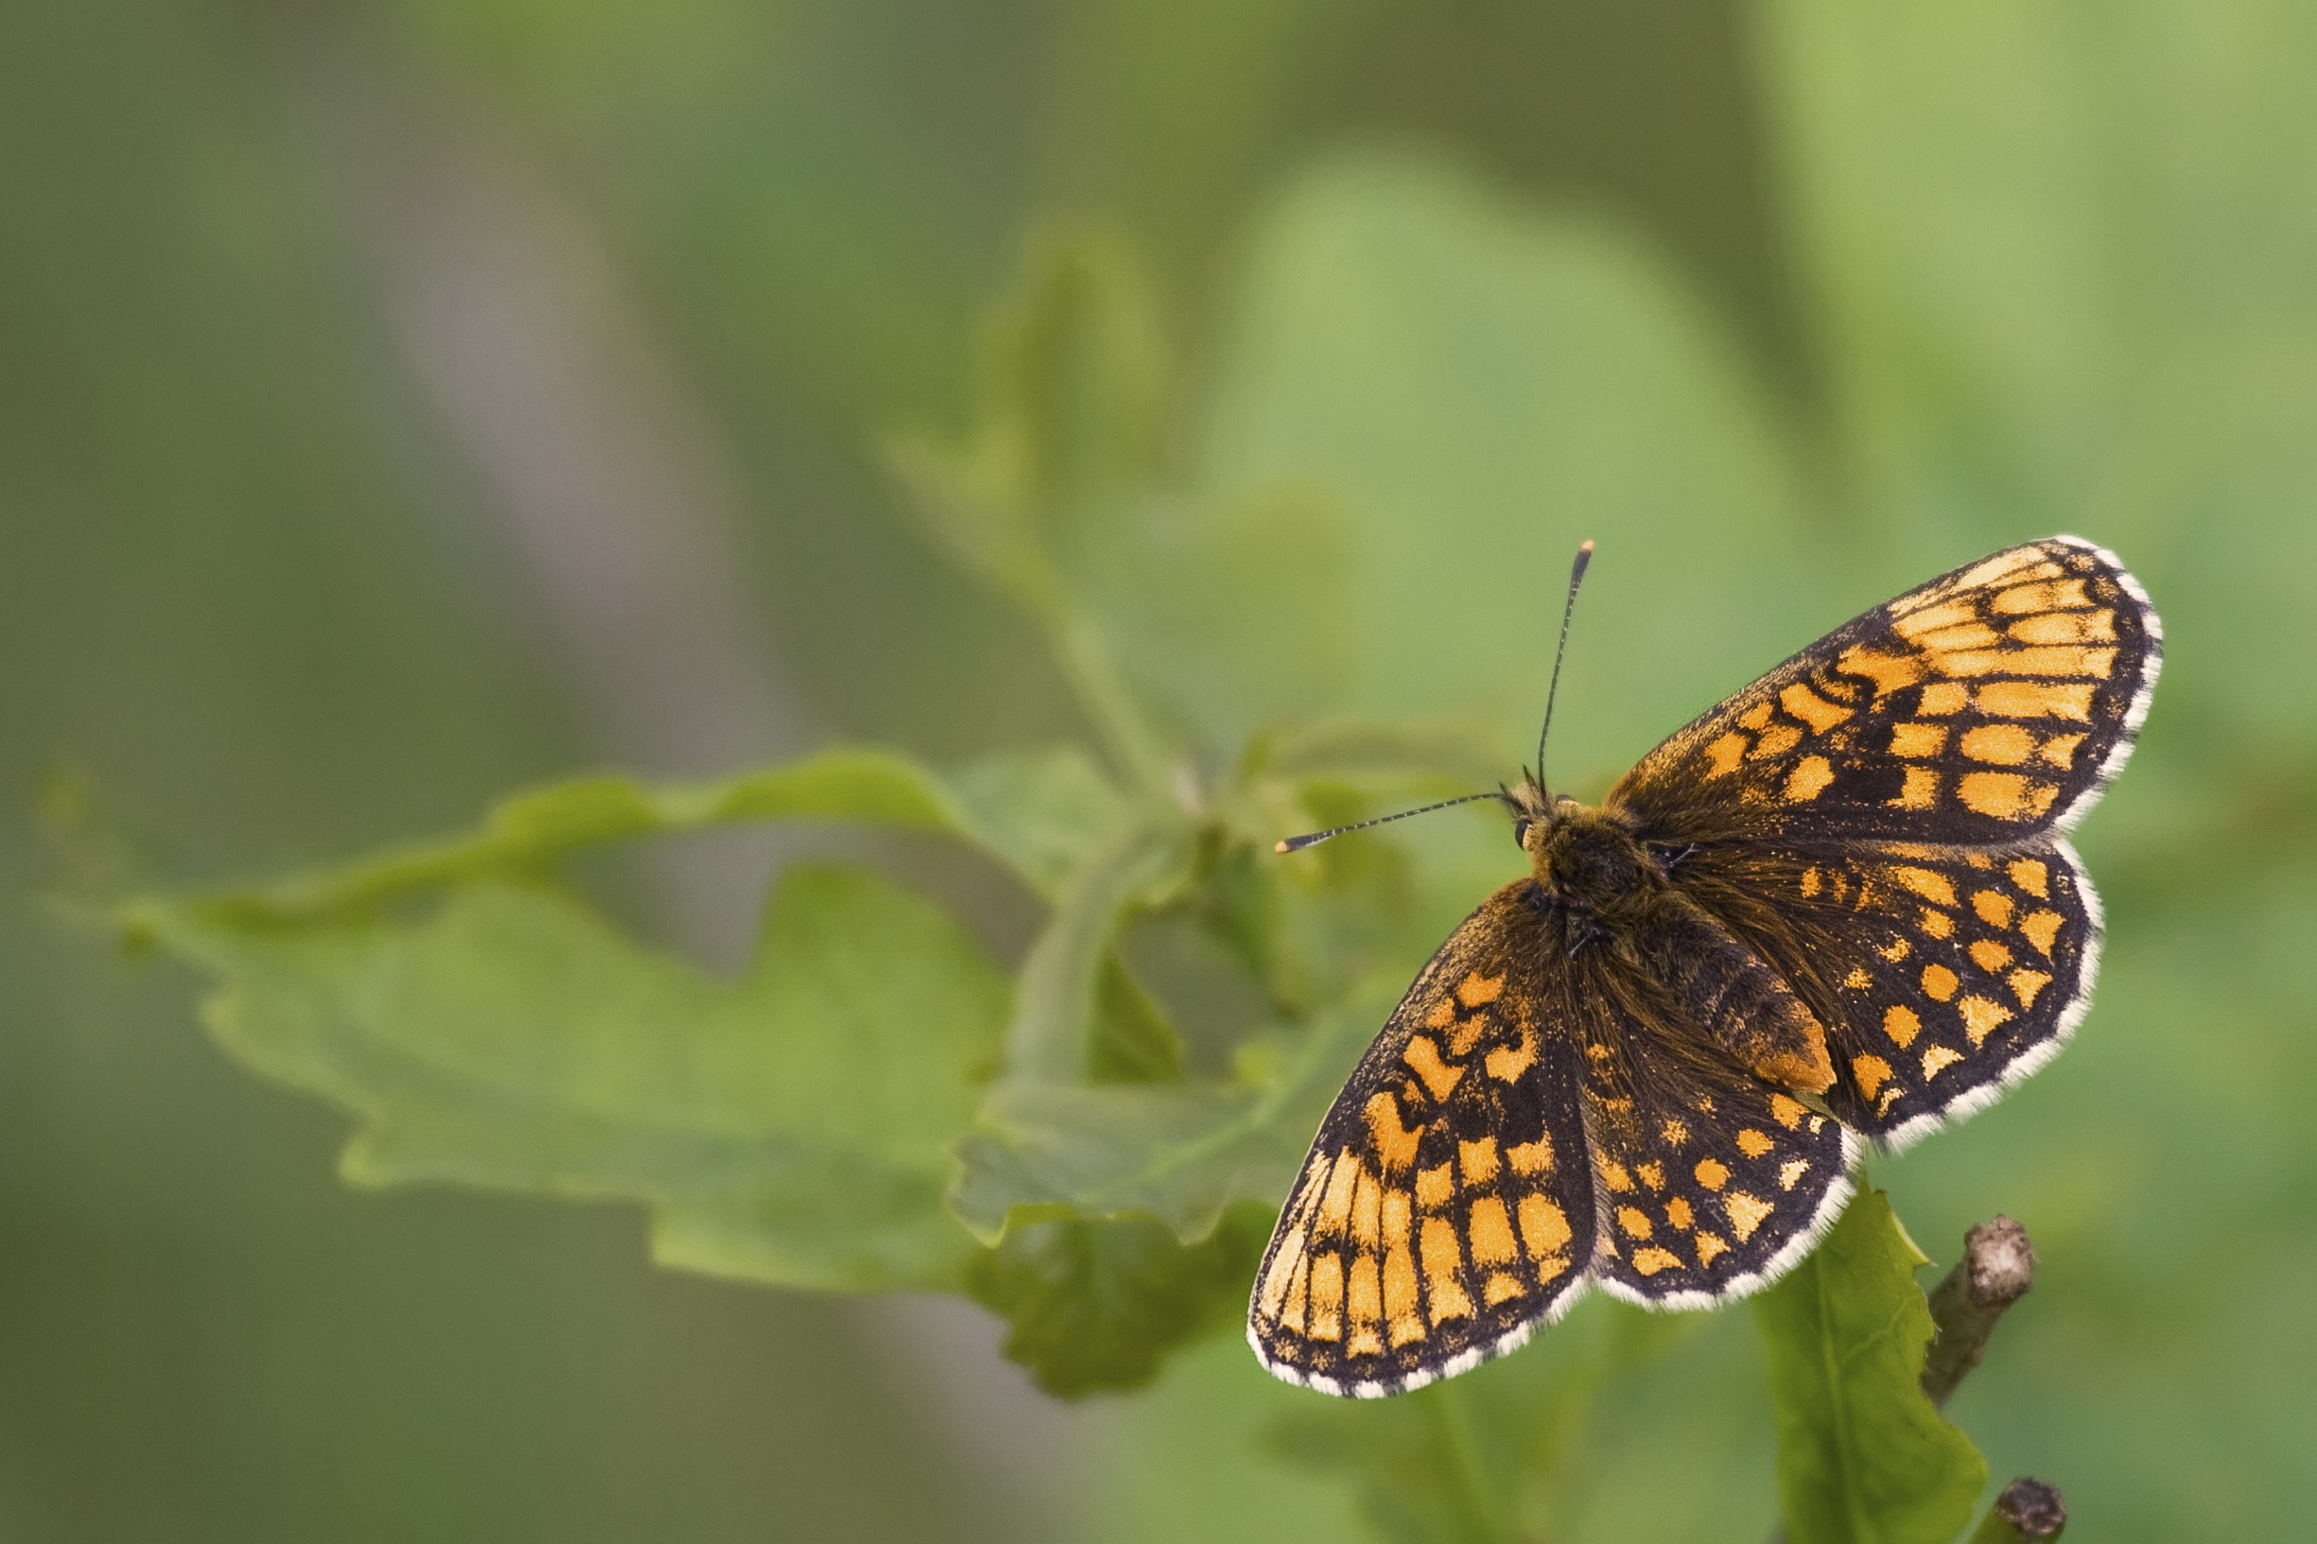
Out of nowhere, the spark.
From nothingness, the immense somethingness.
Lord God, Creator of the Universe,
Hear our prayer,
Witness our awe,
Accept our thanks--
For this Earth on which we live and thrive;
For all that is, every element in Creation,
Every plant and beast and insect,
Every person, in all times and places.
Out of your goodness and love, the Earth came to be.
Out of your everlasting power,
Came the multiplicity of everything that is.

We pray, this day—
Hold us accountable,
Guide us in your ways—
To protect, to serve, to hold precious
This glorious Earth in all its abundance.
Give us wisdom, that we may be faithful to your will.
Give us restraint in our use of resources;
That this Earth on which we live,
This earth, that you made and sustain,
Will pass to our children, generation upon generation.
We pray in your Holy Name. AMEN.

