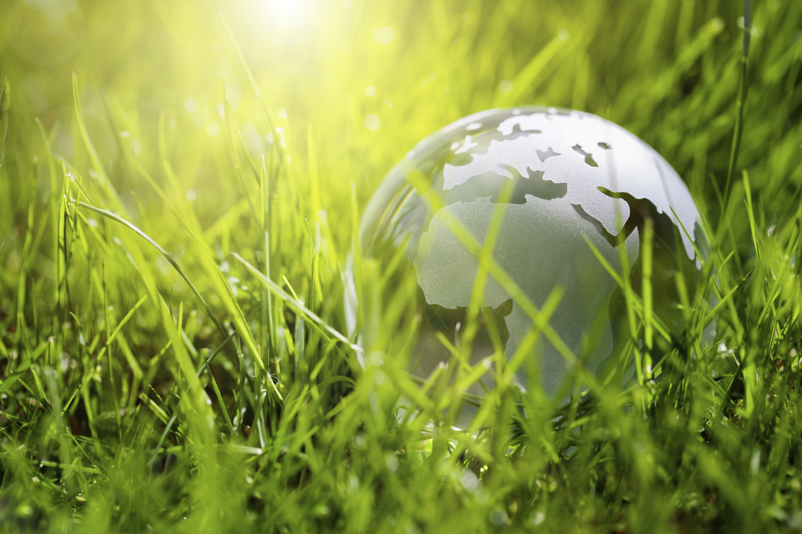
“The earth is the Lord’s and all that is in it, the world and all who dwell therein.” (Psalm 24)
Let us come together to celebrate God’s creation and commit ourselves to protecting the Earth. From ancient times human beings have praised God as the Creator. Along with the gift of life, God expects human beings to take responsibility for stewardship of all that is precious and life-giving.

Psalm 8
O Lord, our Lord, how awesome is your name through all the earth!
You have set your majesty above the heavens! …
When I see your heavens, the work of your hands,
The moon and stars that you set in place ─
What are humans that you are mindful of them,
Mere mortals that you care for them?
Yet you have made them little less than a god,
crowned them with glory and honor.
You have given them rule over the works of your hands,
Put all things at their feet:
All sheep and oxen, even the beasts of the field,
The birds of the air, the fish of the sea,
And whatever swims the paths of the seas.
O Lord, our Lord, how awesome is your name through all the earth!

O Lord, we honor you and praise you for the gift of life and the awesome responsibility you have given us to be good stewards of this earth, our home. May we be ever mindful of the fragility and interconnectedness of all creation. Help us to be wise in our use of resources. Guide us to live so as to preserve the beauty and goodness of the earth for ourselves and for all generations to come. Amen.

