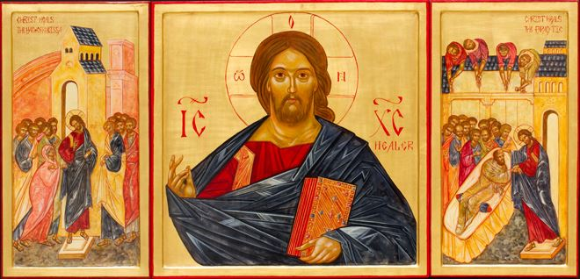
Call to Prayer
Let us be still in the presence of God and one another.

Reflection
Each of us called as healers, leaders and members of our communities. We know that we will experience challenges and that we have the gifts to face them. Remaining faithful to the struggles ahead requires us to remain connected. Connected to each other - strengthening existing relationships and creating new ones. Connecting to our call and craft, the art of medicine, and always reminding connected to God, who has guided and gifted us for our ministry of healing.

Scripture Reading
Jesus Sends the Twelve, Luke 9:1-6

From the Holy Gospel according to Luke:
Jesus now called the Twelve together and gave them power and authority to overcome all demons and to cure diseases. He sent them forth to proclaim the reign of God and heal the afflicted. Jesus advised them: “Take nothing for the journey, neither walking staff nor traveling bag; no bread, no money. No one is to have two coats. Stay at whatever house you enter and proceed from there. When people will not receive you, leave that town and shake its dust from your feet in testimony against them.” So they set out and went from village to village, spreading the good news everywhere and curing diseases.

The Gospel of the Lord.
All: Praise to you, Lord Jesus Christ!

Blessing of Hands Prayer

Consider your hands, lay them on your lap or on the table in front of you. Flex your fingers. Rotate your wrists. Notice how your hands feel and how they move. Consider the words of Saint Teresa of Avila:

Christ has no body now on earth but yours; no hands but yours; no feet but yours.
Yours are the eyes through which the compassion of Christ must look out on the world.
Yours are the feet with which He is to go about doing good.
Yours are the hands with which He is to bless His people.

Please respond to the following: Bless my hands to bless others.

Heavenly Father, bless my hands to bless others.

Gentle these hands as they offer comfort to those in times of crisis.

All: Bless my hands to bless others.

Purify these hands as they wash in to encounter each patient.

All: Bless my hands to bless others.

Open these hands to collaborate well for the good of those I serve.

All: Bless my hands to bless others.

Strengthen these hands when the mornings are early and the nights are late.

All: Bless my hands to bless others.

Settle these hands when it is time to rest.

All: Bless my hands to bless others.

All are invited to come forward to have their hands blessed or anointed.

