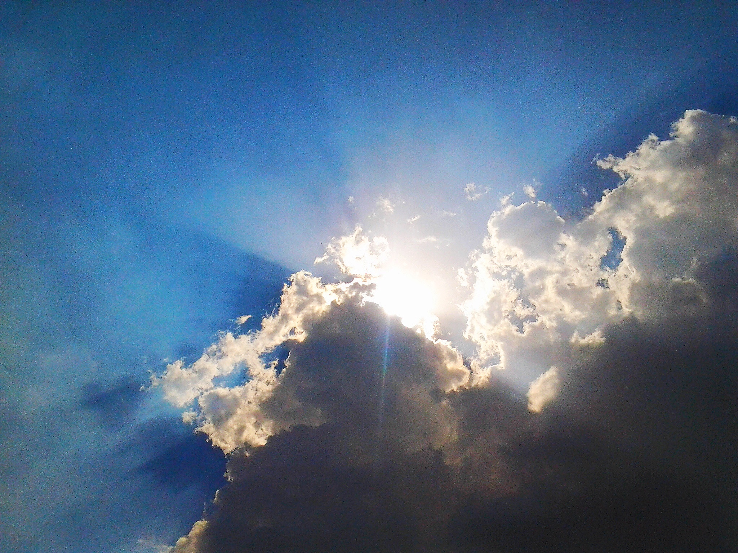
O Lord, you who separated the waters in the beginning,
Who caused the Red Sea to divide to bring your people out of slavery,
Who gave us your rainbow as a sign of your promise never to destroy all of your creation by flood,
Restore our land, our homes, our faith in your goodness,
And show us again how you bring good out of all suffering and loss.
Give us the resources and strength, we ask, to rebuild, replant, start over where necessary,
And show us that you are the loving Creator and Savior. Amen.

