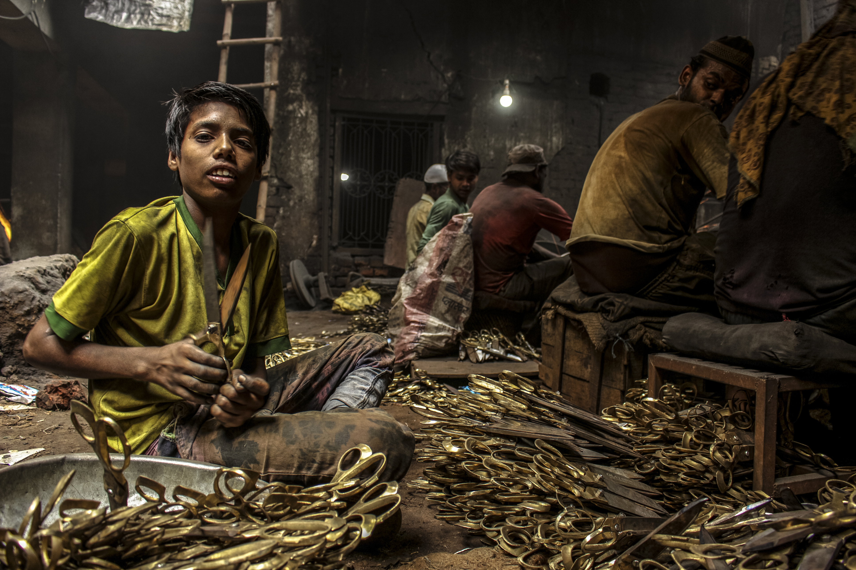
According to the International Labor Organization more than 40 million people worldwide are victims of modern slavery. Although modern slavery is not defined in law, it is used as an umbrella term covering practices such as forced labor, debt bondage, forced marriage and human trafficking. Essentially, it refers to situations of exploitation that a person cannot refuse or leave because of threats, violence, coercion, deception and/or abuse of power. In addition, more than 150 million children are subject to child labor, accounting for almost one in 10 children around the world.

Today, on this International Day for the Abolition of Slavery, we pray …

For people who are trafficked; May they find freedom from fear and harm and courage to live in hope.
Let us pray to the Lord.

For people who traffic others; May they find freedom from greed and violence and courage to live with justice.
Let us pray to the Lord.

For people who work to prevent trafficking; May they find freedom from threats and webs of untruths and courage to live in peace.
Let us pray to the Lord.

God of compassion and mercy, just as you helped Aaron and Moses as they spoke boldly to Pharaoh on behalf of the Hebrew slaves in Egypt, help us speak up for modern slaves around the world and even in our own back yards. You gather the outcast, heal the broken hearted and bind up their wounds; please bring liberty and freedom to all whose lives are entangled in slavery and trafficking in our world today. Lift up the downtrodden and tread wickedness into the dust: We make our prayer through Christ our Lord, Who lives and reigns with you and the Holy Spirit in perfect freedom, One God, now and forever. Amen.

Portions adapted from Modern Slavery prayer resources.docx (togetherinsussex.org.uk)

