INTRODUCTION
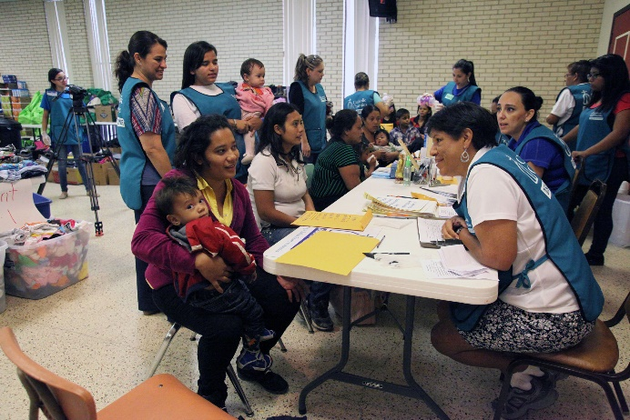
The assertion that humans are created in the divine image is repeated three times in the first chapter of the book of Genesis. Humans are imago dei, or the image of God. Each of us, all of humanity as a collective, bear the goodness, beauty, creativity and love of the One who made us. We have been bombarded in these last months with images of people fleeing —caravans of men, women and children on planes, trains, busses, on foot — all in search of a safe and more flourishing life:

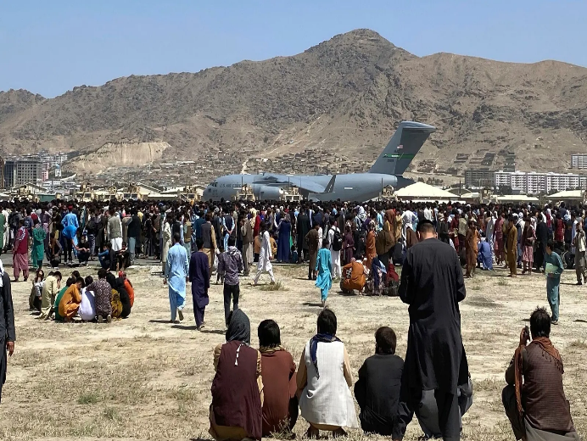
A life where food is shared by family and friends,
uninterrupted by gunfire.

A life where families might go to sleep peacefully, without fear of being awoken in the night by violence or disarray.

A life where educational pursuits are afforded to all who desire them, regardless of their sex, financial background and ability.

Do we not all seek this for ourselves and our children?

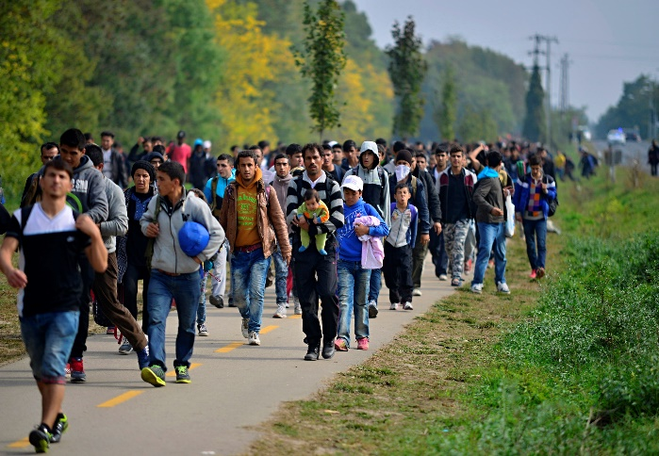
REFLECTION
As you gaze on the images of these countless faces of God, choose one and let your imagination wander:

Where are they going?

What do they seek?

Who have they left behind?

To whom do they turn?

What will they miss about their forgone home?

What do they hope for their new one?
In the classic novel To Kill a Mockingbird, Atticus reminds his daughter Scout: “You never really understand a person until you consider things from their point of view … until you climb in their skin and walk around in it.”

How are you being called to see those who are different with fresh eyes?

How can you offer yourself in support of their journey?

CLOSING
May God’s life-giving Spirit move every human heart. May we see one another as God sees us – see God in every face we encounter – especially those who are different than us and those who are struggling.

May we be moved to crumble the barriers that divide us, may suspicions disappear, and hatred cease. May our loving service bring wholeness and health to ease the transition of migrants and refugees so that we may be signs of your love in the world.

Let us close with the prayer offered by Pope Francis in his World Day of Migrants and Refugees message:

Holy, beloved Father,
your Son Jesus taught us
that there is great rejoicing in heaven
whenever someone lost is found,
whenever someone excluded, rejected or discarded
is gathered into our “we”,
which thus becomes ever wider.
We ask you to grant the followers of Jesus,
and all people of good will,
the grace to do your will on earth.
Bless each act of welcome and outreach
that draws those in exile
into the “we” of community and of the Church,
so that our earth may truly become
what you yourself created it to be:
the common home of all our brothers and sisters. Amen.

