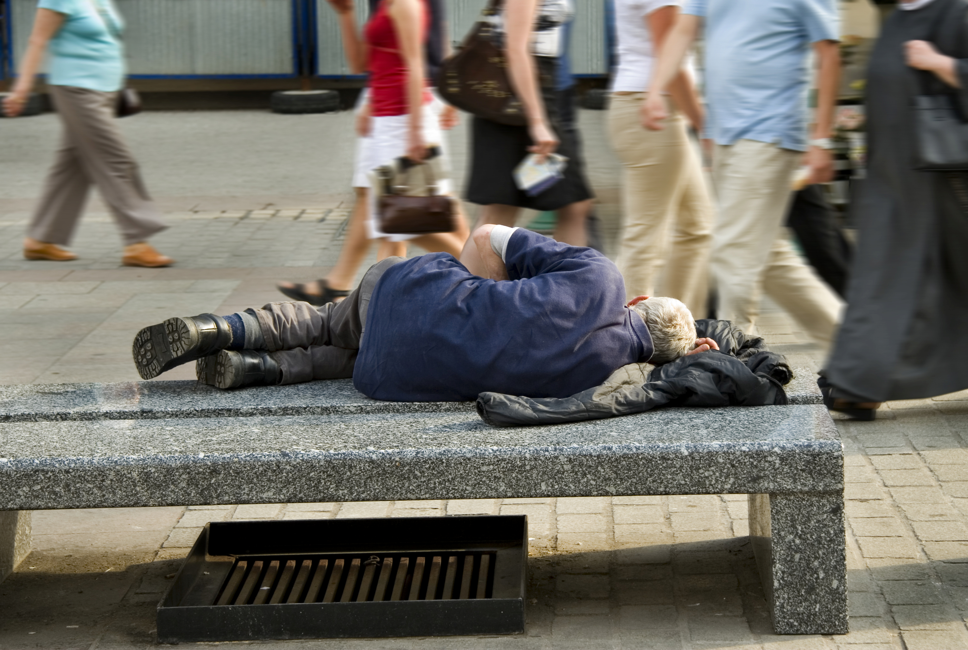
The United Nations General Assembly proclaimed February 20 as the first World Day of Social Justice in 2007. Observance of this day supports efforts of the international community in poverty eradication, the promotion of full employment and decent work, gender equity and access to social well-being and justice for all. A particular focus for this day is the blight of forced labor,
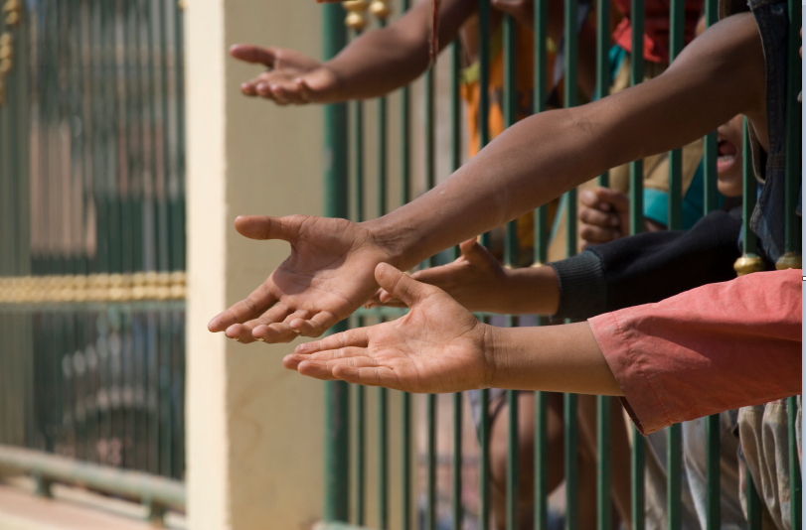
including debt bondage, human trafficking, sweatshop or farm workers kept there by clearly illegal tactics and paid little or nothing, and other forms of modern slavery.

Let us pray for God’s will for all people and for the elimination of institutionalized systems of inequality and oppression.

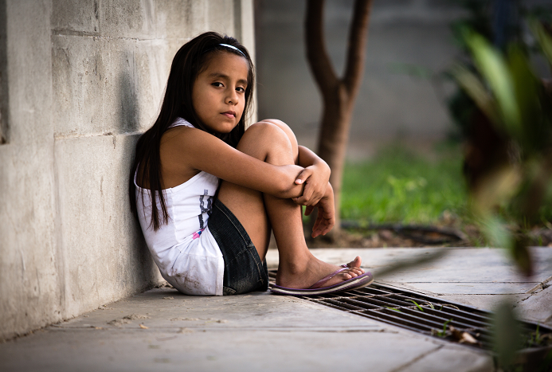
Look with pity, O God, upon the people of the earth
who live with injustice, terror, disease and death
as their constant companions.

Help us to eliminate cruelty to these our neighbors,
our brothers and sisters
throughout the world.

Strengthen those who spend their lives
establishing equal protection of the law
and equal opportunities for all.

Grant that every one of us
may enjoy a fair portion of the riches of the earth
and flourish as you intend.

We pray in the name of the God of All. Amen.

Related sites:

http://www.un.org/en/events/socialjusticeday/

http://www.usccb.org/about/international-justice-and-peace/index.cfm

