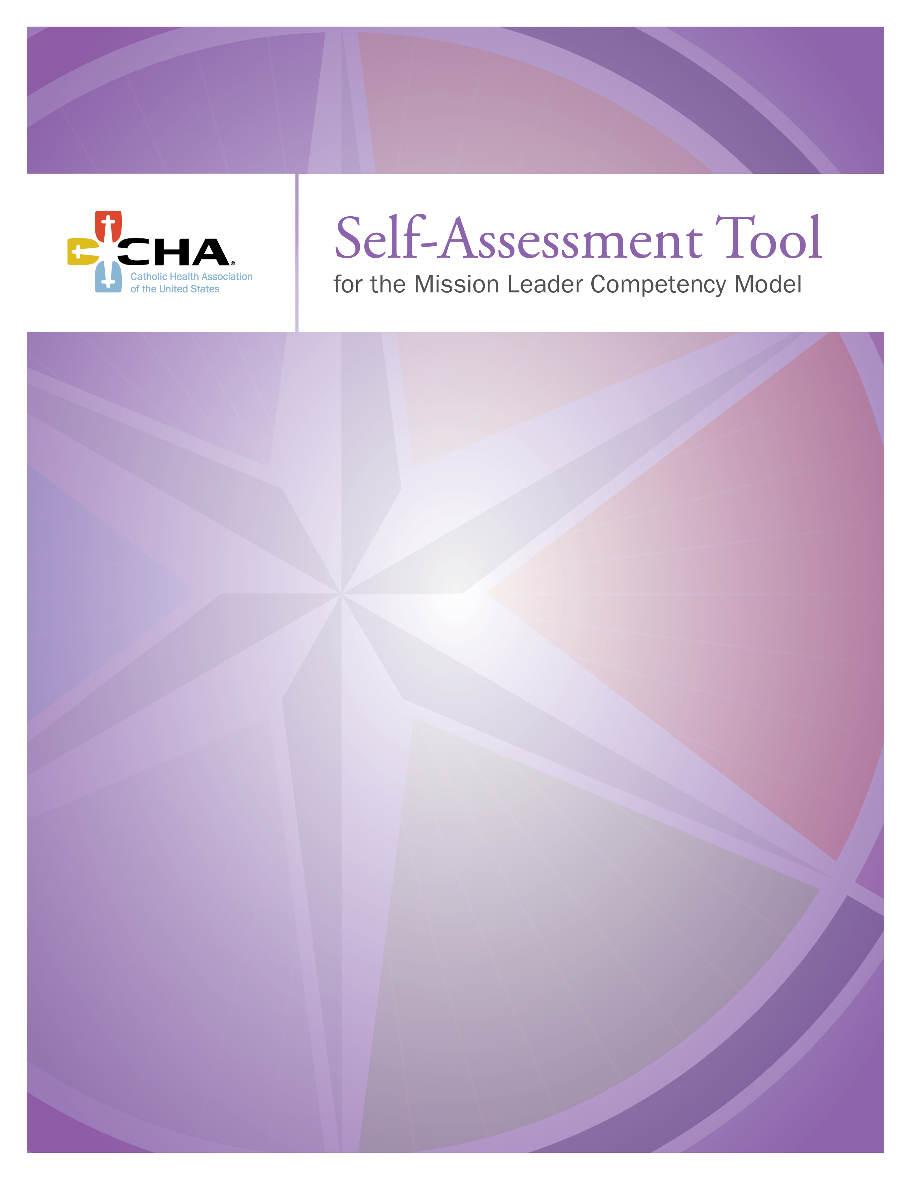

The Mission Leader Competency Model 2

Personal Qualifications 4

Leadership 6

Theology 8

Spirituality 11

Ethics 13

Organizational Management 15

Resources for Your Use 17

CHA Programs for Mission Leaders 18

The Catholic Health Association is pleased to offer this Self-Assessment Tool for
the Mission Leader Competency Model. Available either electronically or hardcopy, it was developed to allow current and potential mission leaders to assess their proficiency in each of the six Mission Leader Competencies. This self assessment can be used privately or in dialogue with a supervisor or mentor in order to identify areas for growth and development.

Background
The role of mission leader appeared in Catholic health care in the 1980s. First filled by religious from sponsoring congregations, the presence of the mission leader assured that, as operational responsibility was transferred to lay leaders, the executive team of
a system or facility included an “expert” in issues related to Catholic identity.

In 1993, 95 percent of mission leaders were religious sisters or priests. In 2013,
that percentage had dropped to about 44 percent. The current trend is moving strongly toward a mission role that is held by well-prepared lay leaders. Recognizing this trend early on, CHA developed a competency model for mission leaders in 1999 that provided guidance to theological education programs for developing curricula for future mission leaders.

Over time, the business of health care has become more multifaceted, as has the complexity of integrating Catholic mission and values into health care operations. This reality calls for a broader range of competencies for mission leaders that enable them
to influence their organizations at every level and in every business decision. CHA
again responded to this reality as it engaged in a collaborative and interactive process
of evaluating the 1999 model and revising it to meet current needs. Starting in 2008, working with The Reid Group of Seattle, Wash., CHA engaged the ministry in a series
of online surveys, personal interviews and focus groups to understand the challenges, needs and hopes of more than 200 CEOs, sponsors, mission leaders and others.
That work was used to create the Mission Leadership Competency Model.

The Mission Leader Competency Model
The Mission Leader Competency Model includes six defined competencies, a Self-Assessment Tool and a Bibliography of articles and books recommended specifically or each competency. The goals of providing these resources are to:

- Reflect competencies and behaviors that are essential for a successful
mission leader now and in the future at the system, regional and facility levels
- Act as a guide for sponsors, CEOs and human resource leaders as they
shape the responsibilities of mission leaders and set criteria for selection of appropriate candidates
- Aide Catholic health care ministries in the development of succession plans
for future mission leaders
- Promote the role of the mission leader as a viable career path for persons in graduate and doctoral theological programs as well as a second career path for current associates and clinicians

Specifically, this assessment tool may be utilized by current mission leaders or those considering mission leadership to assess their proficiency in each of the six competencies. The assessment process includes a self rating for each competency, a description of evidence that supports the rating and the identification of specific steps to address areas for growth.

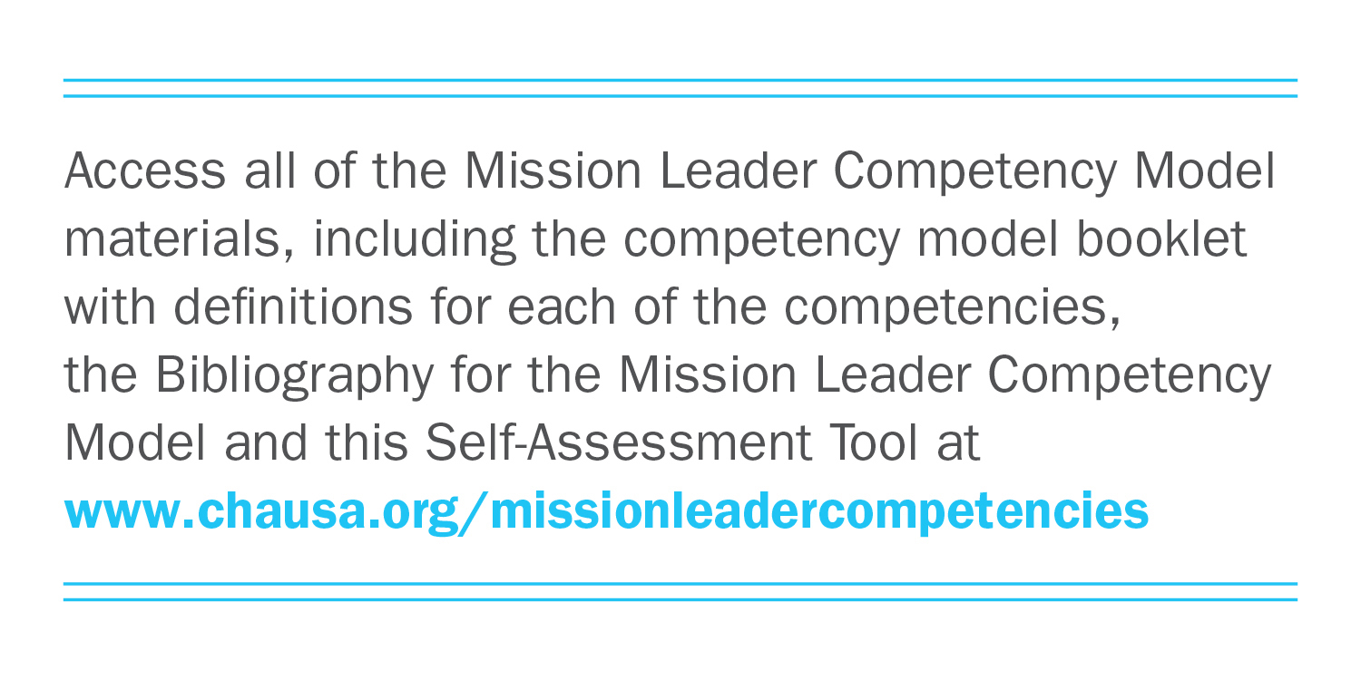

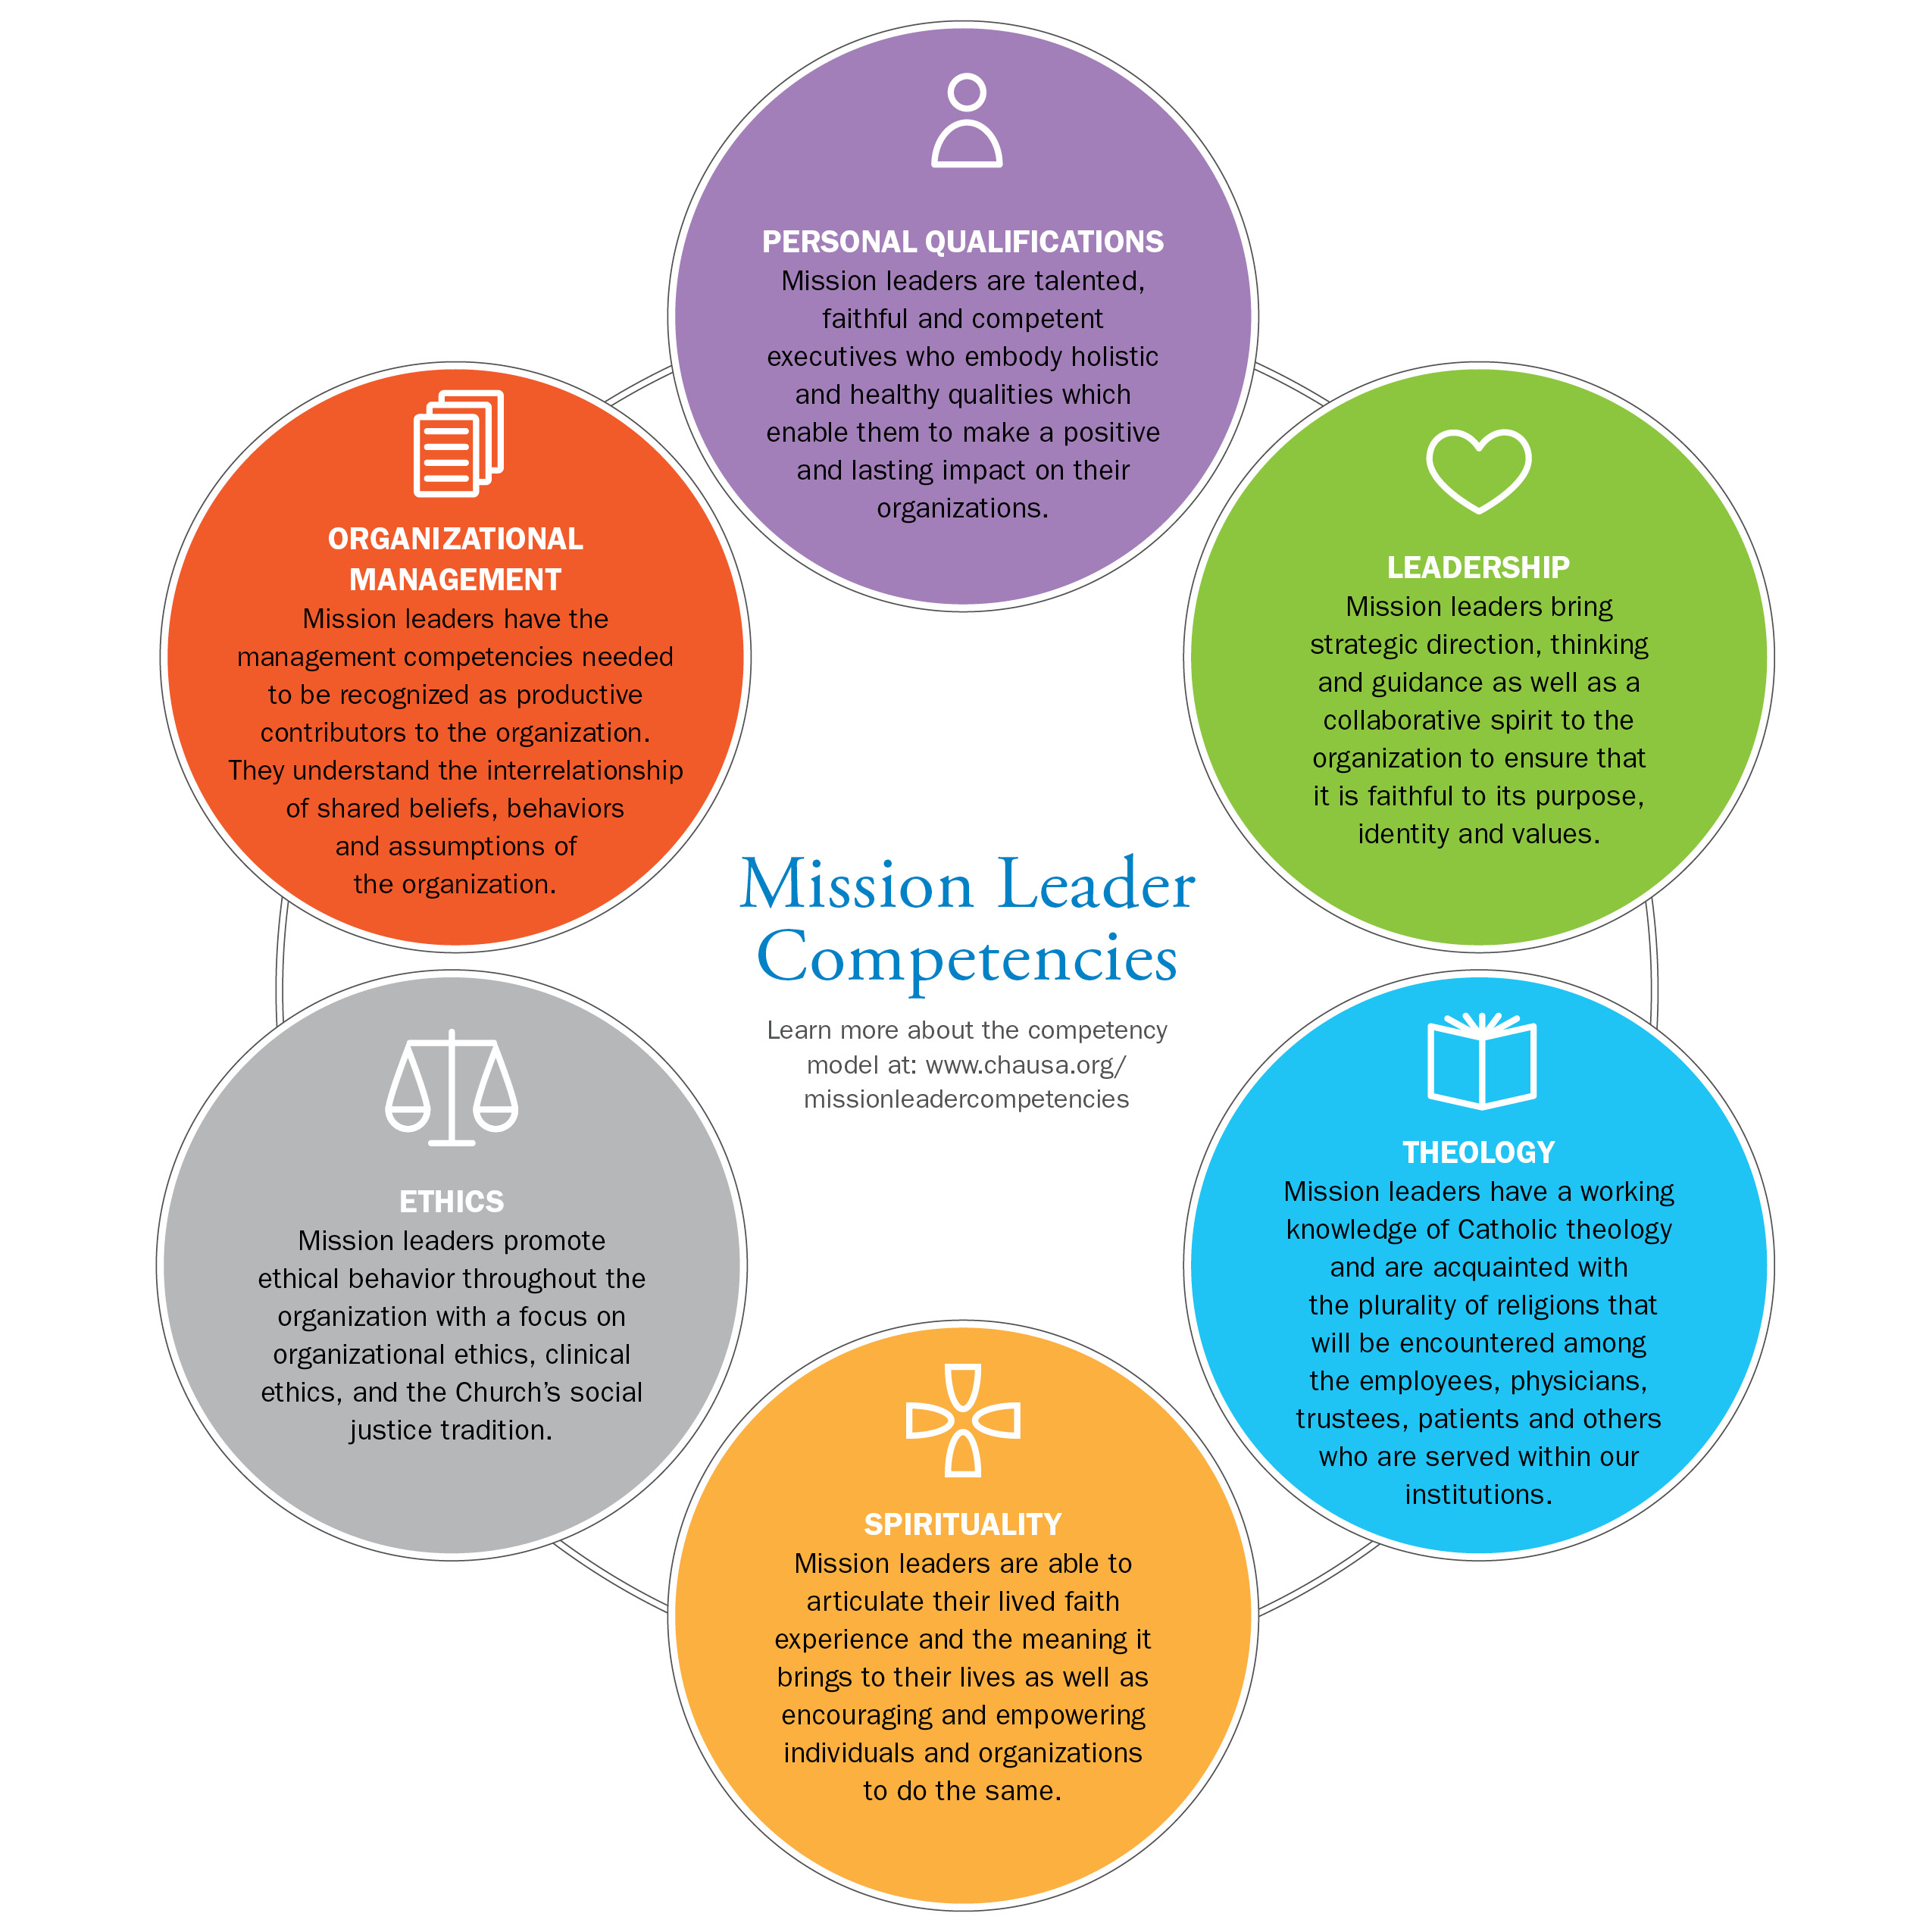

PERSONAL QUALIFICATIONS: Mission leaders are talented, faithful and competent executives who embody holistic and healthy qualities which enable them to make a positive and lasting impact on their organizations.
- Well formed in the Catholic tradition.
EVALUATION: Very Low (1) Low (2) Moderate (3) High (4) Very High (5)

EVIDENCE: ACTION STEPS:

- Persons of faith who model a collaborative style of servant leadership.
EVALUATION: Very Low (1) Low (2) Moderate (3) High (4) Very High (5)

EVIDENCE: ACTION STEPS:

- Committed to the mission and values of their health care organization as a ministry.
EVALUATION: Very Low (1) Low (2) Moderate (3) High (4) Very High (5)

EVIDENCE: ACTION STEPS:

- Capable of establishing mutually beneficial relationships with diverse groups of people.
EVALUATION: Very Low (1) Low (2) Moderate (3) High (4) Very High (5)

EVIDENCE: ACTION STEPS:

- Living a practical integrated spirituality.
EVALUATION: Very Low (1) Low (2) Moderate (3) High (4) Very High (5)

EVIDENCE: ACTION STEPS:

- Knowledgeable about contemporary health care delivery systems and about ethical issues facing the field.
EVALUATION: Very Low (1) Low (2) Moderate (3) High (4) Very High (5)

EVIDENCE: ACTION STEPS:

- Manifesting personal presence characterized by honesty, integrity and caring.
EVALUATION: Very Low (1) Low (2) Moderate (3) High (4) Very High (5)

EVIDENCE: ACTION STEPS:

- Inspiring and motivating others to be committed to the organization’s mission, values, vision and goals.
EVALUATION: Very Low (1) Low (2) Moderate (3) High (4) Very High (5)

EVIDENCE: ACTION STEPS:

- Engaging in life-long learning, self reflection and development.
EVALUATION: Very Low (1) Low (2) Moderate (3) High (4) Very High (5)

EVIDENCE: ACTION STEPS:
LEADERSHIP: Mission leaders bring strategic direction, thinking and guidance as well as a collaborative spirit to the organization to ensure that it is faithful to its purpose, identity and values.
- Strategic Leader
- Articulates and makes operational the organization’s mission and values as a credible driving force for the common good.
EVALUATION: Very Low (1) Low (2) Moderate (3) High (4) Very High (5)

EVIDENCE: ACTION STEPS:

- Models a leadership style that is collaborative, flexible and goal oriented.
EVALUATION: Very Low (1) Low (2) Moderate (3) High (4) Very High (5)

EVIDENCE: ACTION STEPS:

- Clearly sees how the mission is integrated within the organization, and has a vision of where it needs to go.
EVALUATION: Very Low (1) Low (2) Moderate (3) High (4) Very High (5)

EVIDENCE: ACTION STEPS:

- Develops, supports and engages in a team approach to leadership.
EVALUATION: Very Low (1) Low (2) Moderate (3) High (4) Very High (5)

EVIDENCE: ACTION STEPS:

- Displays effective leadership in complex settings marked by religious, cultural and work style diversity.
EVALUATION: Very Low (1) Low (2) Moderate (3) High (4) Very High (5)

EVIDENCE: ACTION STEPS:

- Prophetic Leader
- Demonstrates a passion for the organization’s mission and interprets it prophetically and appropriately for varied audiences, both internal and external.
EVALUATION: Very Low (1) Low (2) Moderate (3) High (4) Very High (5)

EVIDENCE: ACTION STEPS:

- Inspires others to live out the mission.
EVALUATION: Very Low (1) Low (2) Moderate (3) High (4) Very High (5)

EVIDENCE: ACTION STEPS:

- Acts with practical knowledge, courage and prudence in conversations and decision making at the executive level of the organization.
EVALUATION: Very Low (1) Low (2) Moderate (3) High (4) Very High (5)

EVIDENCE: ACTION STEPS:

- Formational Leader
- Helps colleagues identify their work as ministry.
EVALUATION: Very Low (1) Low (2) Moderate (3) High (4) Very High (5)

EVIDENCE: ACTION STEPS:

- Forms board members and co-workers throughout the organization to integrate the mission in their work using effective group skills and principles of adult learning.
EVALUATION: Very Low (1) Low (2) Moderate (3) High (4) Very High (5)

EVIDENCE: ACTION STEPS:

- Analyzes and assesses the organization’s health particularly related
to mission and values.
EVALUATION: Very Low (1) Low (2) Moderate (3) High (4) Very High (5)

EVIDENCE: ACTION STEPS:

- Mediates and facilitates conflict management processes, as appropriate.
EVALUATION: Very Low (1) Low (2) Moderate (3) High (4) Very High (5)

EVIDENCE: ACTION STEPS:

THEOLOGY: Mission leaders have a working knowledge of Catholic theology and are acquainted with the plurality of religions that will be encountered among the employees, physicians, trustees, patients and others who are served within our institutions.

- Pastoral Theology
- Integrates Scripture and the basic principles and doctrines of Catholic theology as articulated by Vatican II and subsequent Church teaching.
EVALUATION: Very Low (1) Low (2) Moderate (3) High (4) Very High (5)

EVIDENCE: ACTION STEPS:

- Connects faith with life using various reflection processes, such as Theological Reflection.
EVALUATION: Very Low (1) Low (2) Moderate (3) High (4) Very High (5)

EVIDENCE: ACTION STEPS:

- Demonstrates a basic understanding of world religions and an appreciation for different faith traditions, beliefs and cultures.
EVALUATION: Very Low (1) Low (2) Moderate (3) High (4) Very High (5)

EVIDENCE: ACTION STEPS:

- Expresses the theological understandings of the organization’s mission and values in multiple and engaging ways.
EVALUATION: Very Low (1) Low (2) Moderate (3) High (4) Very High (5)

EVIDENCE: ACTION STEPS:

- Communicates the relevance of theology to the organization’s vision,
strategies and operations.
EVALUATION: Very Low (1) Low (2) Moderate (3) High (4) Very High (5)

EVIDENCE: ACTION STEPS:

- Understandings of Church
- Expresses an authentic understanding and orientation to the Catholic Church as articulated by Vatican II and subsequent Church teaching.
EVALUATION: Very Low (1) Low (2) Moderate (3) High (4) Very High (5)

EVIDENCE: ACTION STEPS:

- Articulates the relationship of Catholic health ministry to the broader ministry
of the Church.
EVALUATION: Very Low (1) Low (2) Moderate (3) High (4) Very High (5)

EVIDENCE: ACTION STEPS:

- Understands and values the significance of sacrament and ritual in the fullness of the healing ministry.
EVALUATION: Very Low (1) Low (2) Moderate (3) High (4) Very High (5)

EVIDENCE: ACTION STEPS:

- Is familiar with the plurality of religious beliefs.
EVALUATION: Very Low (1) Low (2) Moderate (3) High (4) Very High (5)

EVIDENCE: ACTION STEPS:

- Applies the moral and social teaching of the Church to the healing ministry.
EVALUATION: Very Low (1) Low (2) Moderate (3) High (4) Very High (5)

EVIDENCE: ACTION STEPS:

- Supports the implementation of the Ethical and Religious Directives for Catholic Health Care Services.
EVALUATION: Very Low (1) Low (2) Moderate (3) High (4) Very High (5)

EVIDENCE: ACTION STEPS:

- Fosters a collegial relationship with the diocesan bishop and connects with other diocesan leaders as appropriate.
EVALUATION: Very Low (1) Low (2) Moderate (3) High (4) Very High (5)

EVIDENCE: ACTION STEPS:

- Canon Law
  - Uses and searches out resources as needed to apply Canon Law
to Catholic health care.
EVALUATION: Very Low (1) Low (2) Moderate (3) High (4) Very High (5)

EVIDENCE: ACTION STEPS:

SPIRITUALITY: Mission leaders bring strategic direction, thinking and guidance as well as a collaborative spirit to the organization to ensure that it is faithful to its purpose, identity and values.

- Personal Spirituality
- Lives out a spirituality expressed through prayer and right relationships.
EVALUATION: Very Low (1) Low (2) Moderate (3) High (4) Very High (5)

EVIDENCE: ACTION STEPS:

- Supports others in integrating human and spiritual development.
EVALUATION: Very Low (1) Low (2) Moderate (3) High (4) Very High (5)

EVIDENCE: ACTION STEPS:

- Finds hope within life’s struggles and challenges.
EVALUATION: Very Low (1) Low (2) Moderate (3) High (4) Very High (5)

EVIDENCE: ACTION STEPS:

- Provides needed resources based on diverse spiritual traditions and needs.
EVALUATION: Very Low (1) Low (2) Moderate (3) High (4) Very High (5)

EVIDENCE: ACTION STEPS:

- Models ongoing spiritual development.
EVALUATION: Very Low (1) Low (2) Moderate (3) High (4) Very High (5)

EVIDENCE: ACTION STEPS:

- Speaks with a prophetic and courageous voice.
EVALUATION: Very Low (1) Low (2) Moderate (3) High (4) Very High (5)

EVIDENCE: ACTION STEPS:

- Communal Spirituality

Develops spirituality in work place practices based on the organization’s mission and core values.
EVALUATION: Very Low (1) Low (2) Moderate (3) High (4) Very High (5)

EVIDENCE: ACTION STEPS:

  - Knows the charism and spirituality of the sponsor organizations and integrates that legacy as appropriate through practice and celebration.
EVALUATION: Very Low (1) Low (2) Moderate (3) High (4) Very High (5)

EVIDENCE: ACTION STEPS:

  - Translates the sponsors’ heritage into today’s realities, challenges and possibilities.
EVALUATION: Very Low (1) Low (2) Moderate (3) High (4) Very High (5)

EVIDENCE: ACTION STEPS:

  - Facilitates adult spiritual formation.
EVALUATION: Very Low (1) Low (2) Moderate (3) High (4) Very High (5)

EVIDENCE: ACTION STEPS:

- Spirituality of Change
- Walks with people during challenging personal and organizational times of change.
EVALUATION: Very Low (1) Low (2) Moderate (3) High (4) Very High (5)

EVIDENCE: ACTION STEPS:

- Fosters genuine hope in the midst of difficulties.
EVALUATION: Very Low (1) Low (2) Moderate (3) High (4) Very High (5)

EVIDENCE: ACTION STEPS:

- Assists people to apply the mystery of Christ’s life, death and resurrection to their experience of change, as appropriate.
EVALUATION: Very Low (1) Low (2) Moderate (3) High (4) Very High (5)

EVIDENCE: ACTION STEPS:

ETHICS: Mission leaders promote ethical behavior throughout the organization with a focus on organizational ethics, clinical ethics and the Church’s social justice tradition.

- Organizational Ethics
- Helps shape a work culture rooted in Gospel values.
EVALUATION: Very Low (1) Low (2) Moderate (3) High (4) Very High (5)

EVIDENCE: ACTION STEPS:

- Informs and promotes dialogue around the Ethical and Religious Directives for Catholic Health Care Services.
EVALUATION: Very Low (1) Low (2) Moderate (3) High (4) Very High (5)

EVIDENCE: ACTION STEPS:

- Facilitates corporate discernment and mission-based decision-making processes.
EVALUATION: Very Low (1) Low (2) Moderate (3) High (4) Very High (5)

EVIDENCE: ACTION STEPS:

- Understands and applies values and principles to the business of health care – issues of management, finance, human resources and networking.
EVALUATION: Very Low (1) Low (2) Moderate (3) High (4) Very High (5)

EVIDENCE: ACTION STEPS:

- Surfaces spoken and unspoken moral assumptions and habitual ways of acting
within an organization.
EVALUATION: Very Low (1) Low (2) Moderate (3) High (4) Very High (5)

EVIDENCE: ACTION STEPS:

- Makes moral mission-based assessments of conditions which impact the workplace and helps shape a just working environment.
EVALUATION: Very Low (1) Low (2) Moderate (3) High (4) Very High (5)

EVIDENCE: ACTION STEPS:

- Justice
- Understands and applies the social tradition of the Church to Catholic health care.
EVALUATION: Very Low (1) Low (2) Moderate (3) High (4) Very High (5)

EVIDENCE: ACTION STEPS:

- Advocates for special care to and with people in poverty, the under-represented and/or those with special needs.
EVALUATION: Very Low (1) Low (2) Moderate (3) High (4) Very High (5)

EVIDENCE: ACTION STEPS:

- Promotes right relationships throughout the organization and the community.
EVALUATION: Very Low (1) Low (2) Moderate (3) High (4) Very High (5)

EVIDENCE: ACTION STEPS:

- Integrates environmental-ecological justice principles within the organization’s role as caregiver, employer, community member and partner.
EVALUATION: Very Low (1) Low (2) Moderate (3) High (4) Very High (5)

EVIDENCE: ACTION STEPS:

- Clinical Ethics
- Assists in interpreting the Ethical and Religious Directives for Catholic Health Care Services in relationship to clinical issues.
EVALUATION: Very Low (1) Low (2) Moderate (3) High (4) Very High (5)

EVIDENCE: ACTION STEPS:

- Works with a variety of health care professionals in identifying values and principles that guide ethical decision-making in clinical matters.
EVALUATION: Very Low (1) Low (2) Moderate (3) High (4) Very High (5)

EVIDENCE: ACTION STEPS:

- Develops and monitors appropriate policies and their implementation.
EVALUATION: Very Low (1) Low (2) Moderate (3) High (4) Very High (5)

EVIDENCE: ACTION STEPS:

ORGANIZATIONAL MANAGEMENT: Mission leaders have the management competencies needed to be recognized as productive contributors to the organization. They understand the interrelationship of shared beliefs, behaviors and assumptions of the organization.
- Communication and Collaboration
- Invites, listens and responds to the voices of colleagues.
EVALUATION: Very Low (1) Low (2) Moderate (3) High (4) Very High (5)

EVIDENCE: ACTION STEPS:

- Exhibits flexibility and collaborates with people throughout the organization.
EVALUATION: Very Low (1) Low (2) Moderate (3) High (4) Very High (5)

EVIDENCE: ACTION STEPS:

- Is knowledgeable about the sponsors’ role and communicates appropriately on issues related to mission and values.
EVALUATION: Very Low (1) Low (2) Moderate (3) High (4) Very High (5)

EVIDENCE: ACTION STEPS:

- Possesses and uses effectively good written and oral communication skills.
EVALUATION: Very Low (1) Low (2) Moderate (3) High (4) Very High (5)

EVIDENCE: ACTION STEPS:

- Business
- Has a working knowledge of the organization’s operations.
EVALUATION: Very Low (1) Low (2) Moderate (3) High (4) Very High (5)

EVIDENCE: ACTION STEPS:

- Makes executive decisions based on the organization’s mission and a functional knowledge of the business and financial realities.
EVALUATION: Very Low (1) Low (2) Moderate (3) High (4) Very High (5)

EVIDENCE: ACTION STEPS:

- Integrates the mission throughout the culture of the organization, using a systems approach.
EVALUATION: Very Low (1) Low (2) Moderate (3) High (4) Very High (5)

EVIDENCE: ACTION STEPS:

- Management
- Leads change and manages the organization effectively with other executives through changing times.
EVALUATION: Very Low (1) Low (2) Moderate (3) High (4) Very High (5)

EVIDENCE: ACTION STEPS:

- Organizes and implements actions around the organization’s goals, strategies and priorities.
EVALUATION: Very Low (1) Low (2) Moderate (3) High (4) Very High (5)

EVIDENCE: ACTION STEPS:

- Empowers and supports the human potential of colleagues.
EVALUATION: Very Low (1) Low (2) Moderate (3) High (4) Very High (5)

EVIDENCE: ACTION STEPS:

- Manages his/her division effectively.
EVALUATION: Very Low (1) Low (2) Moderate (3) High (4) Very High (5)

EVIDENCE: ACTION STEPS:

- Engages in effective succession planning.
EVALUATION: Very Low (1) Low (2) Moderate (3) High (4) Very High (5)

EVIDENCE: ACTION STEPS:

Resources for Your Use

CHA is a resource for education, formation and networking. The association offers a wide range of resources for mission leaders as well as their colleagues.

Bibliography for the Mission Leader Competency Model
This bibliography provides important articles and books for each of the six Mission Leader Competencies. It is available at www.chausa.org/missionleadercomptencies

Annotated Bibliography For Mission Leaders
This annotated bibliography provides important articles and books
under the topics of Catholic identity, leadership, mission, organizational ethics, pastoral
care, spirituality in the workplace, sponsorship and clinical ethics. It is available at http://www.CHAUSA.org/missionleaderbibliography

Resources For Mission Leaders
CHA offers a compendium of resources mission leaders can use for their own formation
and that of their associates. From Catholic social tradition and ethics to human trafficking, immigration, formation and advocacy, CHA’s website is your place to connect with
need-to-know information.

Go to www.CHAUSA.org to access our many offerings.

CHA Programs for Mission Leaders

As the ministry’s resource for information and programs, CHA hosts several annual events that are relevant and timely for mission leaders.

- Annual Catholic Health Assembly
The Catholic Health Assembly is the largest annual convening of Catholic health care leaders. It draws executives, governance leaders and religious women and men who sponsor Catholic health care organizations for two-and-a-half days of education, networking and spiritual renewal.

- Navigating the Landscape or Catholic Health Care Ethics: A Program for
Mission Leaders
Designed to accommodate mission leaders’ busy schedules and to optimize learning and interaction, the program features an ideal blend of in-person meetings and online sessions to understand key principles in clinical and organizational ethics. In addition to providing a foundation in Catholic social teaching and moral principles vital to Catholic health care, the curriculum will examine critical issues around beginning and end-of-life care, ethics committees, partnerships, shaping organizational culture, new frameworks for ethics beyond the acute care setting and more. Faculty are noted ministry ethicists and theologians who have years of experience in Catholic health care ethics.

- Catholic Health Care Ethics (Loyola)
This program, co-sponsored by CHA and The Neiswanger Institute for Bioethics & Health Policy at Loyola University Chicago Stritch School of Medicine, brings together leading moral theologians and health care ethicists to provide a primer in Catholic health care ethics, to apply conceptual resources to current problems and to confront moral challenges on the horizon for Catholic health care providers.

- Community Benefit 101
Planning and reporting community benefit are now key functions of Catholic-sponsored and other not-for-profit health care organization. The Catholic Health Association, the leader in the community benefit field for 20 years, offers a one-and-a-half day seminar that covers the basics of community benefit.

- Ecclesiology and Spiritual Renewal Program
Conducted in Rome, this program for senior leaders of Catholic health organizations delivers historical and practical knowledge of the institutional structure and ministries of the Roman Catholic Church. Also, through experiences of prayer and ritual and visits to sacred sites in Rome and Assisi, participants explore their own spirituality and how it affects their leadership. This program is invitation only with participants selected by system CEOs.

- Foundations of Catholic Health Care Leadership
This introduction to the foundations of the Church's health ministry will help senior managers, especially those who are new to Catholic health care, as well as managers in partner organizations, to more effectively carry out their responsibilities as ministry leaders. Participants will engage in interactive presentations, dialogue and reflections that address concepts critical to leadership in Catholic health ministry.

- Essentials for Leading Mission in Catholic Health Care
(formerly titled Prophetic Voice)
This program is designed specifically for new mission leaders and those considering entering the ministry of mission. The goal of this program is to assist mission leaders in achieving greater effectiveness in their responsibilities in the organizational life and daily operations of the Catholic health ministry.

- Basics of Health Care Finance
Financial performance, like mission, is a source of constant reflection in faith-based health care. Very often for new leaders, knowledge of health care finance is gained more by experience than by formal training. This in-person program offers an introduction to basic elements of finance that are often the subject of discussion for many executive and management teams, as well as governing bodies. Leaders without formal knowledge of finance as it pertains to non-for-profit health care should be equipped with a basic understanding of these elements in order to offer appropriate input on important decisions. The presentations cover the basic elements of health care finance and the basic tools used to assess and track the financial performance of a health care organization.

- System Mission Leadership Forum
This annual invitation-only gathering is designed for mission leaders at the system and large region levels. The forum allows leaders optimal time to network with each other, share successful practices and other information and address current challenges in mission for the Catholic health care ministry.
