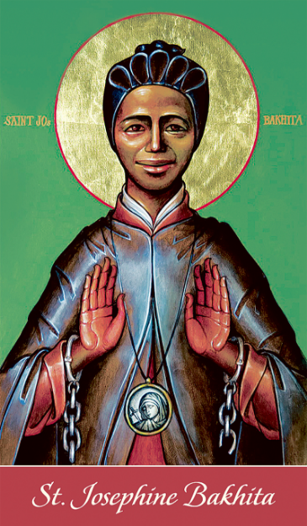
The Pontifical Council for Justice and Peace and the International Union of Superiors General has designated February 8 as an annual day of prayer and awareness against human trafficking. February 8 is the feast day of St. Josephine Bakhita, who was kidnapped as a child and sold into slavery in Sudan and Italy. Once Josephine was freed, she became a Canossian nun and dedicated her life to sharing her testament of deliverance from slavery and comforting the poor and suffering. She was declared
a Saint in 2000.

Opening Prayer

Leader: God of the oppressed and enslaved, today we remember your daughter, St. Josephine Bakhita, who was born in Sudan, kidnapped and sold into slavery, was later freed and spent her life with the Canossian sisters in Italy. We remember her life, how she knew the misery of enslavement and the hope and joy of freedom. As we pray today, we ask you to encourage us in the spirit of St. Josephine to remember and help all those who may still find freedom and hope in you. Amen.

Reading: Exodus 3:7-10

Reader: A reading from the book of Exodus

The LORD said: I have witnessed the affliction of my people in Egypt and have heard their cry against their taskmasters, so I know well what they are suffering. Therefore I have come down* to rescue them from the power of the Egyptians and lead them up from that land into a good and spacious land, a land flowing with milk and honey, the country of the Canaanites, the Hittites, the Amorites, the Perizzites, the Girgashites, the Hivites and the Jebusites. Now indeed the outcry of the Israelites has reached me, and I have seen how the Egyptians are oppressing them. Now, go! I am sending you to Pharaoh to bring my people, the Israelites, out of Egypt.

The word of the Lord.

All: Thanks be to God.

Reflection

Thousands of years ago, the Israelites were enslaved, exploited and oppressed, their lives and labor used to build up the kingdom in Egypt and not the kingdom of God. Today many people's lives are used and abused, seen as a means to an end or an opportunity for exploitation and gain. In a joint statement, the bishops of the United States and Mexico stated that “trafficking in persons–in which men, women, and children from all over the globe are transported to other countries for the purposes of forced prostitution or labor–inherently rejects the dignity of the human person and exploits conditions of global poverty.” We still have much to learn and much work to do when it comes to the enslavement and trafficking of our brothers and sisters around the globe. The story of enslaving people has continued. But we also must not forget the story of hope in Exodus and that of St. Josephine Bakhita. Freedom is not impossible. A life of flourishing and knowing the love of God are worth working for and can be achieved.
- How have I heard the cry of those suffering and enslaved in the world?
- Where along the path to freedom is God sending me?

Litany of Prayer to St. Josephine

Leader: Together let us ask St. Josephine to walk with us in all the ways needed to ensure freedom and flourishing for all God’s beloved children.

Reader 1: May we work to create communities of support for those who are most vulnerable, that all may remain safe and loved: All: St. Josephine, pray for us.

Reader 2: May we boldly envision a world without slavery, that we may never hesitate to believe that the enslaved can all be freed: All: St. Josephine, pray for us.

Reader 1: May we walk with survivors and provide them with the care and resources to reclaim their lives and flourish in freedom: All: St. Josephine, pray for us.

Reader 2: May we offer survivors of trafficking the space to grieve what has been lost and the space to grow toward hope and forgiveness: All: St. Josephine, pray for us.

Reader 1: May we strive to uphold the dignity of the human person in all areas of our lives, that we may continue building a culture of life where each human is seen and loved as a child of God and slavery could not even be imagined: All: St. Josephine, pray for us.

Closing Prayer:

Leader: Lord remember your beloved daughter, St. Josephine, and all your children here on earth who suffer. Let us conclude today by praying together the bishops’ prayer to St. Josephine Bakhita:

All: St. Josephine Bakhita, you were sold into slavery as a child and endured untold hardship and suffering. Once liberated from your physical enslavement, you found true redemption in your encounter with Christ and his Church.

Oh St. Bakhita, assist all those who are trapped in a state of slavery; Intercede with God on their behalf so that they will be released from their chains of captivity. Those whom we enslave, let God set free.

Provide comfort to survivors of slavery and let them look to you as an example of hope and faith. Help all survivors find healing from their wounds. We ask for your prayers and intercessions for those enslaved among us. Amen.

