Let Us Be Still, Let Us Be Peace
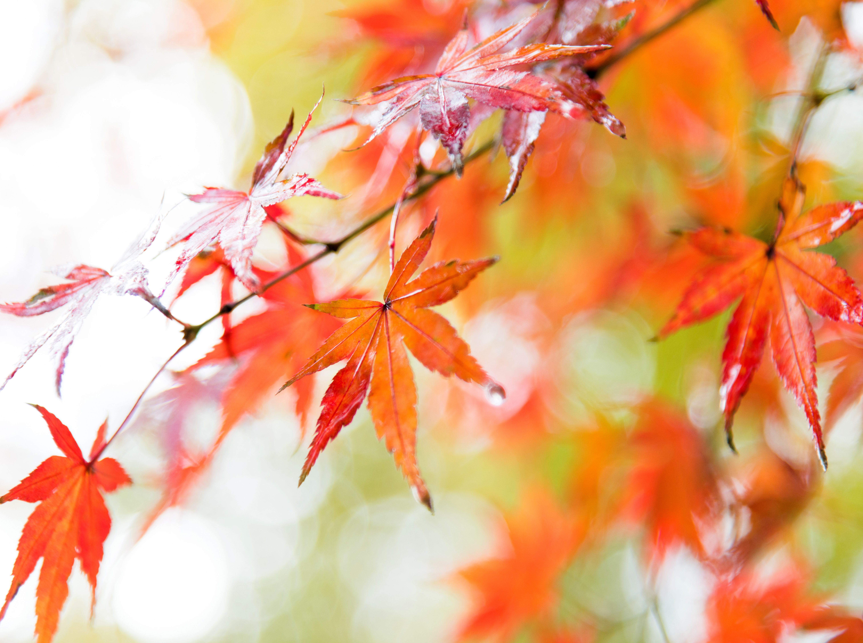
Call to Prayer:
How beautiful on the mountains are the feet of those who bring good news, who proclaim peace, who bring good tidings, who proclaim salvation, who say to Zion, “Your God reigns!” Isaiah 53:7

Reading:
A passage from Pope Francis’ encyclical, Laudato Si …
The universe unfolds in God, who fills it completely. Hence, there is a mystical meaning to be found in a leaf, in a mountain trail, in a dewdrop, in a poor person’s face. The ideal is not only to pass from the exterior to the interior to discover the action of God in the soul, but also to discover God in all things.

Reflection:
Our world is full of noise and hustle; many of us live in one-hour increments, shuttling to and from activities, interacting more and more with technology and less and less with others. It is difficult to see the mystical meaning in a leaf, make time to go to a mountain trail or look away from our phone to notice the dewdrop.

Called from his life of wealth, privilege, excitement and parties to one of simplicity, peace, prayer and connection with the natural world, Saint Francis provides a model for us. As we celebrate and remember Francis’ love of the earth, care for animals, commitment to the poor and sick, let us use today as an invitation to consider how we might make space, as Francis did, for simplicity, peace, prayer and nature in our lives.

The great spiritual leaders have consistently taught us that peace is an inside job. By cultivating peace in ourselves, we can become instruments of God’s peace in the world.

(over)
Prayer:
One: God speaks through the psalmist,
“Be still, and know that I am God” (Psalm 46:10)
In this moment, here and now, you are invited to stillness in God’s presence.
To be still and know.
To breathe deeply and dwell in the peace of God.

[Pause for three deep cleansing breaths.]

Let us pray, as included in The Prayer of Saint Francis, to be made instruments of God’s peace.
All: Lord, make me an instrument of your peace.

One: Let us remember, “Peace comes from within, do not seek it without.” [Buddha]
All: Lord, make me an instrument of your peace.

One: Let us remember, “A peaceful heart sees a celebration in any village.” [Hindu proverb]
All: Lord, make me an instrument of your peace.

One: Let us remember, “Each one has to find their peace from within. And peace, to be real, must be unaffected by outside circumstances.” [Gandhi]
All: Lord, make me an instrument of your peace.

One: Let us remember, “As you announce peace with your mouth, make sure that you have greater peace in your hearts, thus no one will be provoked to anger or scandal because of you. Let everyone be drawn to peace and kindness through your peace and gentleness. Peace comes from the heart, and if peace can transform from within, then peace will guide the brothers as they travel through the world: Whatever house they enter, let them first say: ‘Peace be to this house.’ Such peace is possible only through the sacrifice of one’s very self.” [Saint Francis of Assisi]
All: Lord, make me an instrument of your peace.

All: God of all graciousness, you call us to yourself through the beauty of the natural world and in the workings of our own hearts. Move in our lives as you moved in the life of Francis of Assisi. Gift us with the peace, simplicity, joy and love of creation that you shared with him. Deepen our interior lives that we may share your peace with a world in need.

