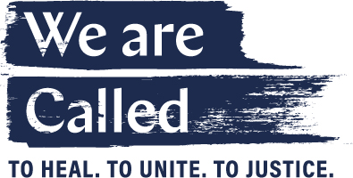

God of All People,
You came as one of us to show how we belong to each other.
You served among us to show how we are to serve one another.
You called us to follow you that we might build a better world together.
God of Wisdom and Compassion,
Renew our minds with your call to humble learning and service.
Refresh our hearts with your call to equity and integrity of community.
Reignite our spirits with your call to justice for our brothers and sisters.
God of Righteousness and Justice,
Make us relentless as we examine the structures that perpetuate inequity.
Make us humble as we lean in to listen and learn what we do not know.
Make of us steady allies and advocates, leveraging the strength of our shared ministry for the good of your people.
Amen.

