A Reflection on the Road to Emmaus for the Easter Season
Reflection

This reflection is offered as a companion to the video The Road to Emmaus, which is part of CHA’s ministry formation offerings. The video is available at www.chausa.org/ministryformation.

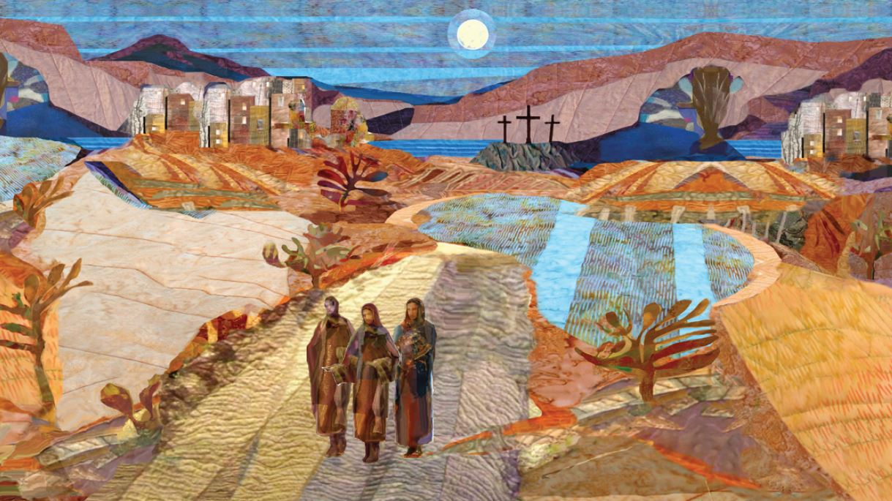
Consider the famous quote from an iconic 1980s movie, “Life moves pretty fast. If you don’t stop and look around once in a while, you could miss it.” At first glance, the parting words of Ferris Bueller may not have much to with the Road to Emmaus or Easter, but the underlying lesson about awareness, presence and perspective are all there.
Two disciples walk from Jerusalem after the events of Jesus’ trial, conviction and death.

Holy Thursday, Good Friday and Holy Saturday were fast days for the disciples. Trauma followed tragedy with no time to process or make sense of what happened. In shock, overcome with grief, the pair are soon joined by a stranger who to their amazement, seems not to know what has transpired. As they walk, the two explain the situation of confusion, torture and loss.

The stranger, who is the risen Jesus unrecognized, tells them the story from a new lens and a larger perspective. Beginning with the foundations of faith in Moses and the prophets witness, the hidden Christ unpacks all the promises of God to show how they point to the paschal mystery of death and resurrection.

Comforted and amazed by their new companion’s perspective, the disciples invite him to join them for their evening meal. As he blessed and broke the bread, they recognized Jesus in this familiar and intimate gesture and knew at once who sat with them. As this new recognition dawned, Christ the messenger disappeared. The two returned to Jerusalem to witness the resurrection of Jesus and share how the empty tomb was not a disappointment, but a promise kept, the covenant fulfilled.

The walk on the road to Emmaus was very likely the first time they could “stop and look around.” In stepping away, the disciples could explore the meaning of the events with greater clarity. This bit of distance gave them a new perspective. When Jesus reminded them of the bigger story of God’s work in the world and the broader picture of salvation, they were able to see what beauty God makes of the world’s brutality.
Life in health care is fast on the slowest days, and it is hard to see the bigger picture when we are hustling to make it to lunch. This second account of the resurrection on a nondescript road outside Jerusalem speaks to us in our busyness, amid everything overstuffed into our days. Every day, every moment, we are called to open our eyes to the broader story of grace, accompaniment and love happening all around us.

To make meaning of our experience, we take the long view and see how goodness, hope and love are resurrected again and again in our lives. Resurrection, the joy and hope of Easter, indeed the person of Jesus, can find us anywhere. In the hallways, bedsides and boardrooms and at our home offices or shared workstations. Our celebrations and grief can all be opportunities to stop, look around and see the sacred in our midst.

We must notice and respond when our hearts burn within us and ask:

Where is God accompanying me on my journey?

Who is the hidden Christ in our midst?

Where is the resurrection playing out now and always?

