God of mystery, who is ever beyond us —
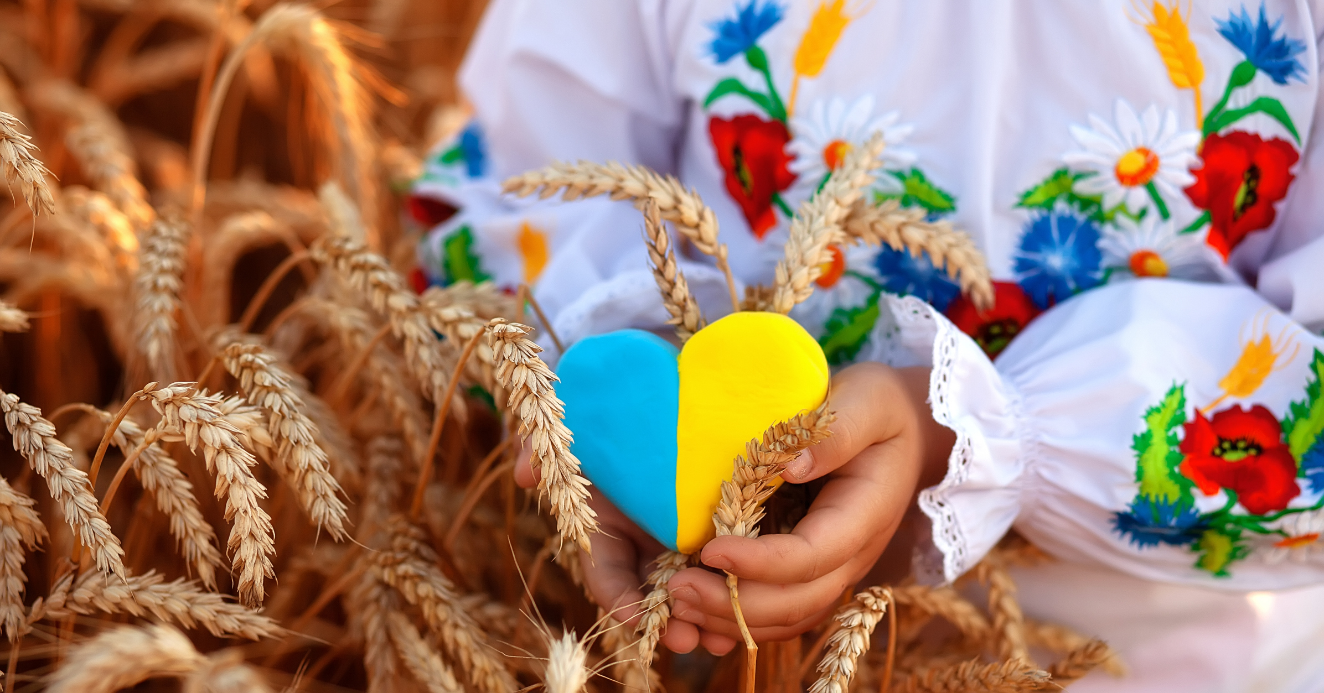
For years now we have faced with courage, with exhaustion, with despair, a common invisible enemy. And while it has been plenty hard, our brothers and sisters in Ukraine now add to that fight a very real, very visible one. An enemy with a name, with a face, with an agenda which goes against the very essence of our shared humanity.
God of mystery, who is ever beyond us —
We do not understand, we do not have answers for why suffering persists; for why caregivers reporting to work are responsible also for their patients’ physical safety from battle; for why mothers and fathers must worry about the roofs over their children’s heads; for why families must leave homes, heirlooms, all they have known for what is unknown, in hopes of preserving some semblance of safety.
God of mystery, who is ever beyond us —
Our souls are weary from the weight of war, from the weight of this despair, from the weight of a conflict that feels all too familiar. We ask how this can be happening, but are left only with the words of your Son:
Peace be with you.
These words of Jesus, so simple, and, yet, amid the complexities of war, peace feels so out of reach.
Peace be with you.

God of mystery, who is ever beyond us —
It feels as though there is so little to be done, so little that we can do from half a world away ...
And so let us choose peace: let us choose peace today, tomorrow, every day. May our work toward peace in our daily decision-making serve as a small act of resistance against evil, may our choices for peace and our offering of peace to others overwhelm the world.
In your name we pray: AMEN.

