But the fact remained, he always reminded me, no matter what people’s preferences, that we are our brother’s keeper, and the unit of society is the family; that we must have a sense of personal responsibility to take care of our own, and our neighbor, at a personal sacrifice…’That is a first principle…Charity is personal. Charity is love.’
- Dorothy Day, recounting Peter Maurin in The Long Loneliness

Throughout its history, the Judeo-Christian tradition has held a special concern for the poor and vulnerable. The anawim—the unloved, the unlovable. The materially poor, the exploited, the abused. To do our work well, we must challenge the subtle temptation to put our wants, our needs, or our goals ahead of those we are called to serve.

Let us reflect on the following questions:

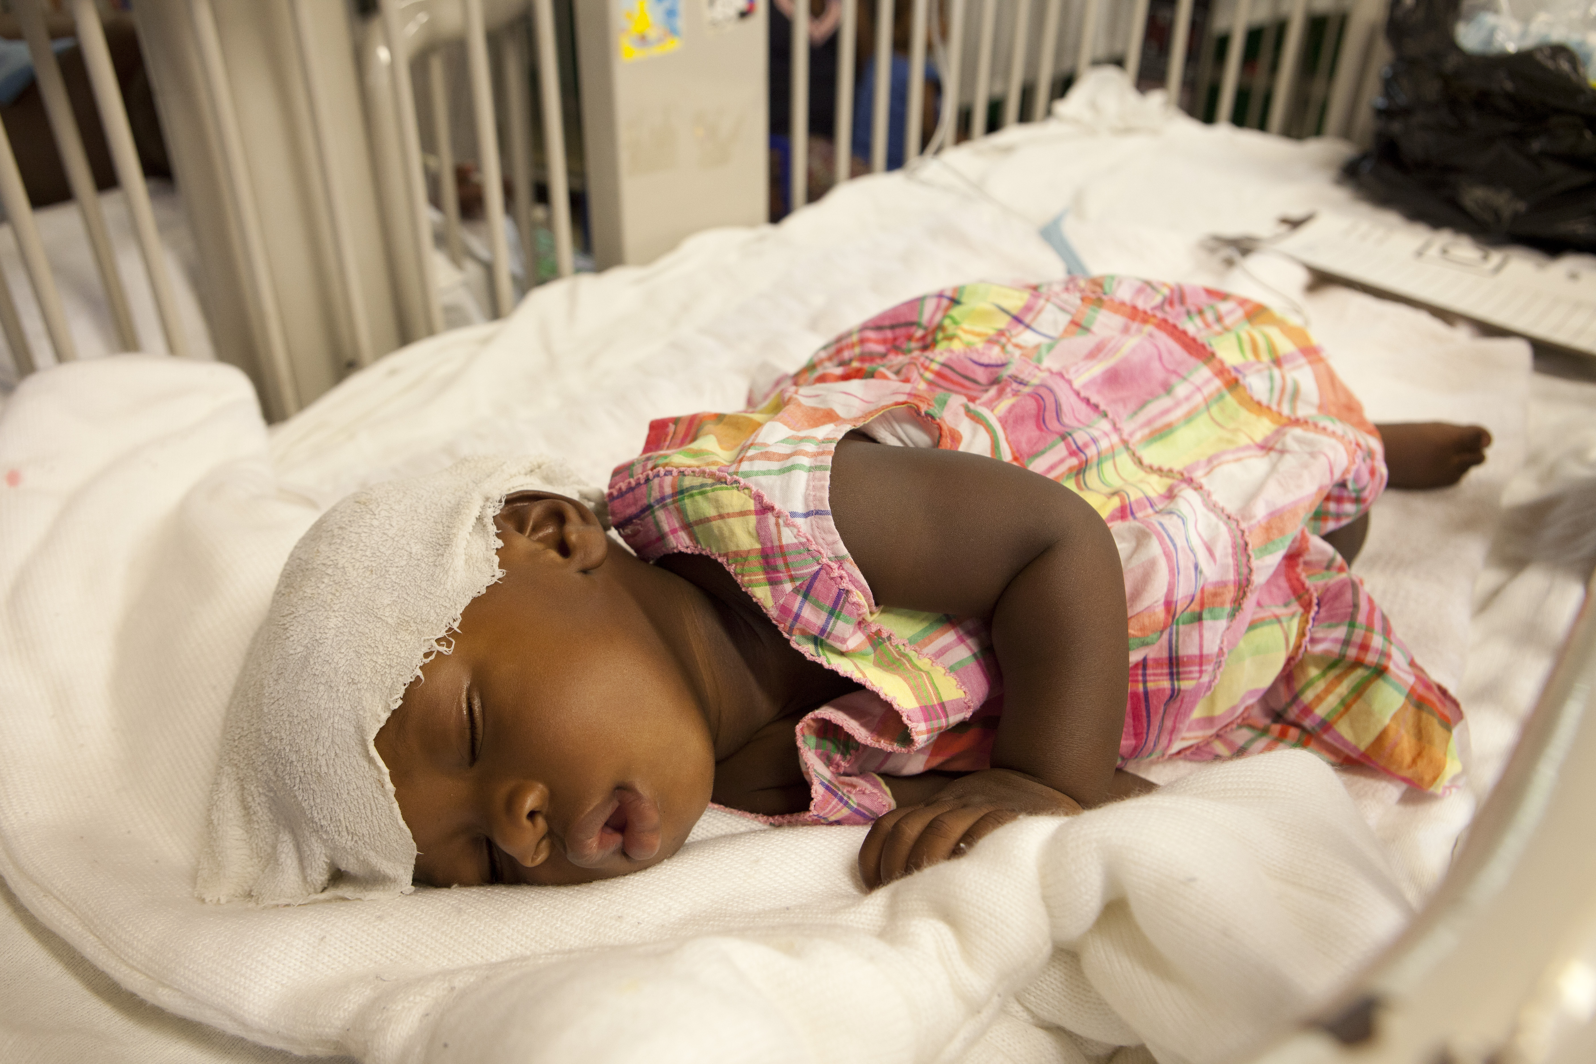
Who are the modern day anawim?

How do we enter into solidarity with those who have been left at the margins? How do we share in their experiences of mistrust, helplessness, of being left behind our global progress?

Do we have a preferential option for the poor? In word or deed?

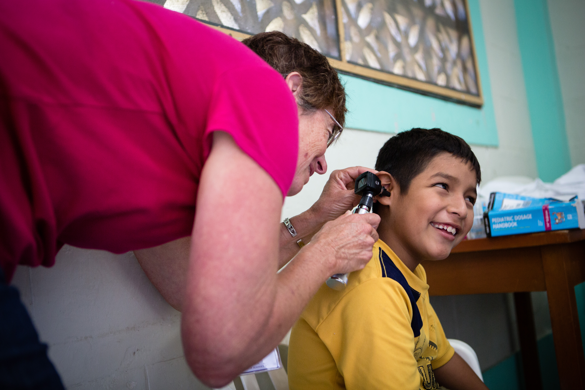
Do we seek out solutions that bring the poor, the underserved, the anawim, to the forefront of our personal and our institutional consciences?

A reading:
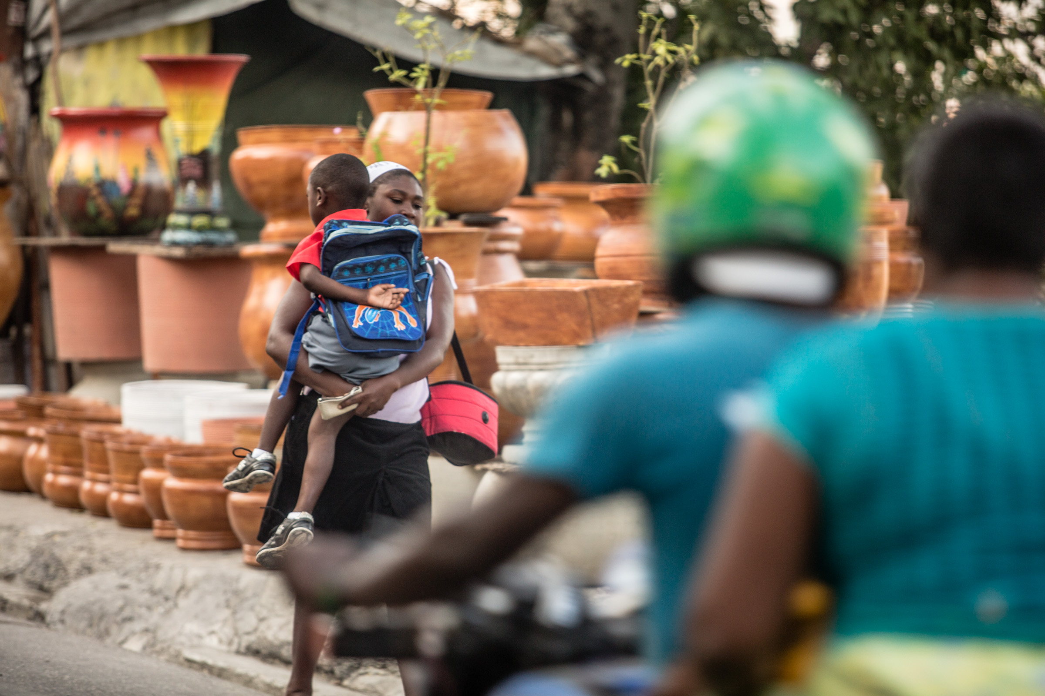
Pope John Paul II has described this special obligation to the poor as "a call to have a special openness with the small and the weak, those that suffer and weep, those that are humiliated and left on the margin of society, so as to help them win their dignity as human persons and children of God."

The prime purpose of this special commitment to the poor is to enable them to become active participants in the life of society. It is to enable all persons to share in and contribute to the common good. The "option for the poor," therefore, is not an adversarial slogan that pits one group or class against another. Rather, it states that the deprivation and powerlessness of the poor
(over)
wounds the whole community. The extent of their suffering is a measure of how far we are from being a true community of persons. These wounds will be healed only by greater solidarity with the poor and among the poor themselves.

- Economic Justice for All: Pastoral Letter on Catholic Social Teaching and the U.S. Economy, United States Conference of Catholic Bishops, 1986

Let us pray …
Good and Gracious God, help us to always see the poor among us. May we always recognize that the person in front of us is Christ-himself. Give us courage to name injustice, to speak on behalf of the voiceless, and to do Your work to bring about the Kingdom of God here on Earth. We ask all of this in Your Name. Amen

