If today you hear God’s voice, harden not your heart.
Psalm 95:8

In the days before refrigerators were common, many people used icehouses to keep their food cold. Essentially walk-in coolers, icehouses had thick walls, no windows and tightly-fitted doors. Ice was cut from frozen streams and lakes in the winter and brought into the icehouses, where large blocks were covered in sawdust to be used in the summer months.

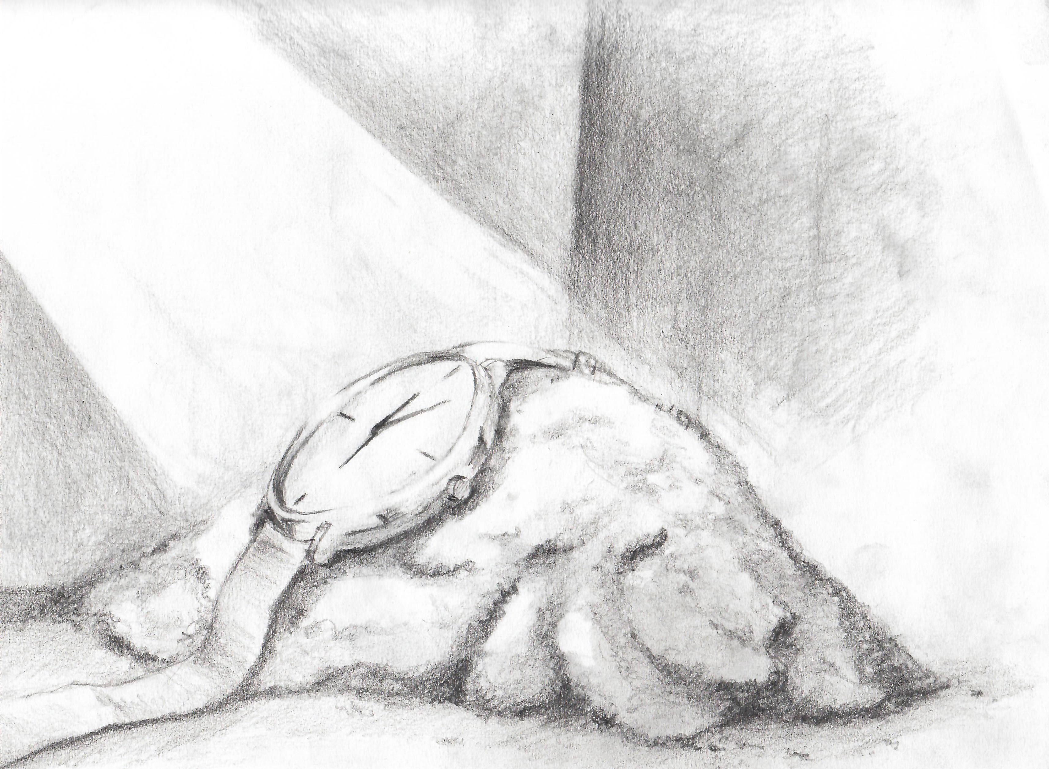
A story is told of a man who lost a valuable watch while working in an icehouse. Though he and his companions searched thoroughly through the sawdust, the watch wasn’t found. The man’s daughter heard about the lost watch and knowing how much it meant to her father, she snuck into the icehouse. A while later she emerged, watch in hand, and returned it to her astonished father who asked how she managed to find it.
“I closed the door,” she replied, “lay down in the sawdust and kept very still. Soon I heard the watch ticking.”

Ash Wednesday begins the Christian celebration of Lent. Forty days of prayer, fasting and almsgiving to prepare believers for the celebration of Easter. A part of Lent is the call to quiet and reflection. A call to still ourselves and consider our faith lives. We cease searching and striving for the external markers of success and fulfillment and settle in to listen to what the still, small voice of God is saying in our lives and in our hearts.
It’s an opportunity to ask ourselves: Am I able to hear the voice of God?

Our lives are filled with noise. From our televisions and computers, tablets, phones and radios, even some gas pumps feature built-in speakers and screens for advertisement. And it’s not just media. Our lives are packed to the brim with things that require attention. In our facilities, monitors are always flashing, often beeping. Residents call out for assistance or need comfort. Calls have to be made. Emails must be answered. Dashboards need attention. Codes, sirens and call lights all require immediate action. While our faith affirms that God is in all of these things, still, Lent calls us away.

Lent calls us to our inner room. To an extra moment of quiet in the car or our office. To linger in the chapel. To wander in the woods. To soften our hearts and listen for the voice of God. The still, small voice that whispers and waits inside of us. Calling us to return. Calling us to faithfulness. Calling us to begin our Lenten journey back home to the God who loves us.

How can you make space in your days this Lent to hear the still, small voice of God in your heart?
Like the watch in the icehouse, what treasure are you seeking on your Lenten journey?

