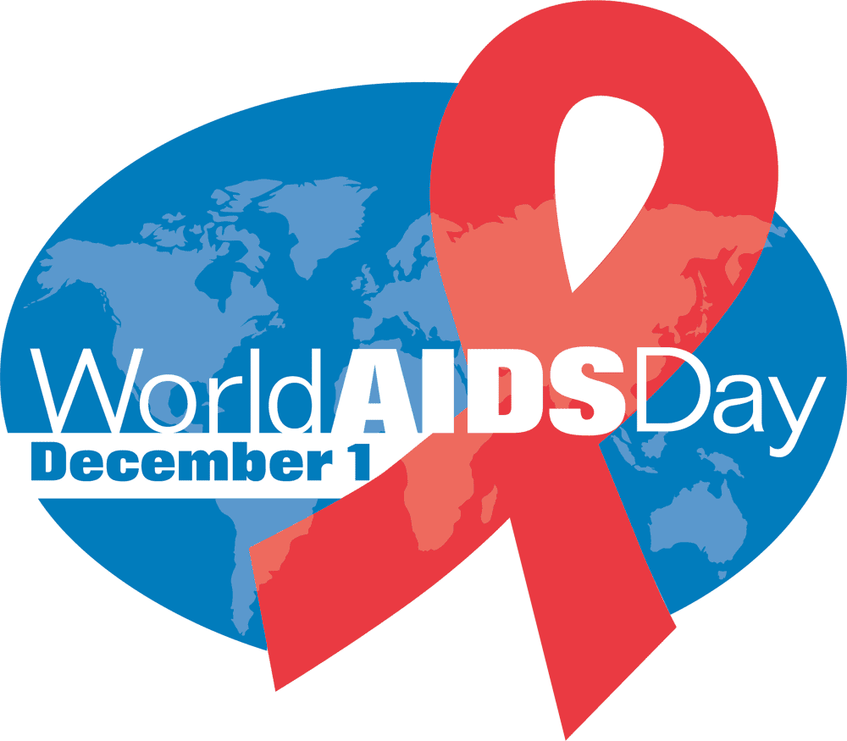
World AIDS Day takes place on the 1st of December each year. It is an opportunity for people worldwide, and especially the men and women in Catholic health ministry who have served those living with HIV/AIDS, to unite in the fight against HIV, to continue to show support for people living with HIV and to commemorate those who have died from an AIDS-related illness. Founded in 1988, World AIDS Day was the first ever global health day.

And so we pray …

God of Promise, today we are mindful of our sisters and brothers suffering with HIV and AIDS. We ask your healing presence on millions of people living with the disease today; particularly the children who are infected or who have been orphaned by the disease. Make of us a safe haven for those who are abandoned, discriminated against and rejected on account of their illness. Inspire us to speak out for a just distribution of health care and medical aid in this country and for generosity in sharing our resources with those struggling under the weight of this epidemic overseas.

As we begin our Advent celebration of waiting in hope for the birth of your Son, let us remember those across the world who wait in hope for a cure. Amen.

