Trees Shedding Their Bark
Adapted from Peeling Away the Layers by Madisyn Taylor

Trees grow up through their branches and down through their roots into the earth. They also grow wider with each passing year. As they do, they shed the bark that served to protect them, but now are no longer big enough to contain them. If we do not allow ourselves to be transformed by what we have known and loved, we cannot expand to our full potential.
Trees need their protective bark to enable the delicate process of transformation to help unwrap new growth and opportunities. Like all trees, our growth in times of transition depends upon our openness and our ability to embrace transformation by opening our hearts as we embrace the invitation to the new. We can only move into the future when we consciously embrace what is ours to do.

Many spiritual teachers believe that we learn to hold more as we learn to let go. We become bigger people who carry our history into new relationships. While it is essential to set and honor all that has been, it is equally important to create space for all that is yet to become part of our life story.
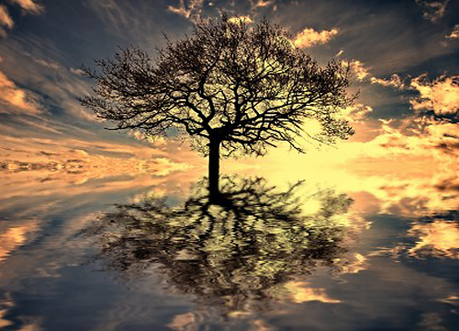
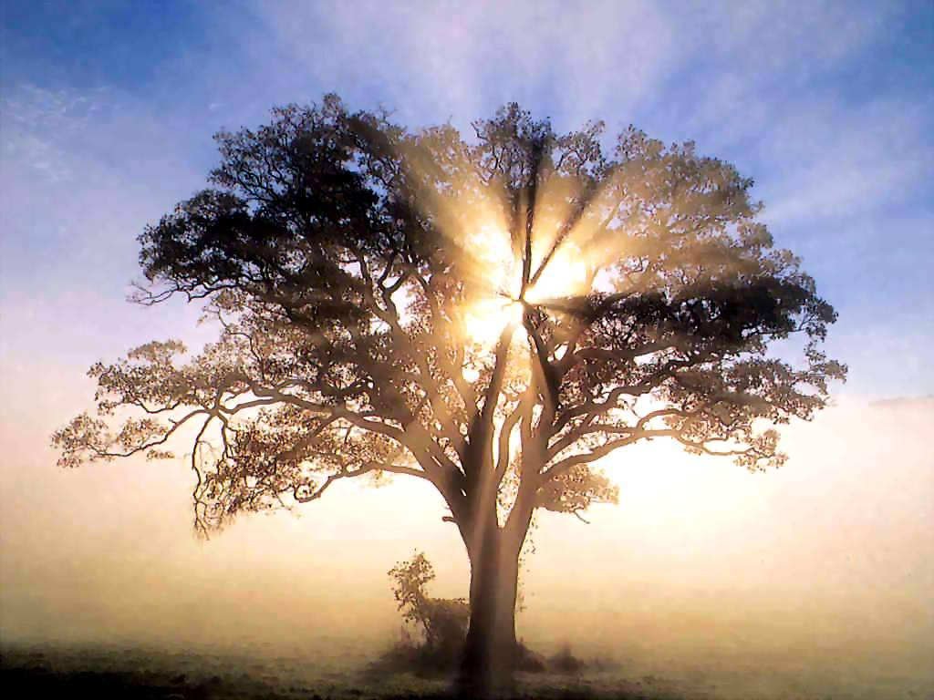

“Today I have grown taller
from walking with the trees.”
~Karle Wilson Baker

