“Christ became obedient to the point of death, even death on a cross. Because of this, God greatly exalted him and bestowed on him the name which is above every name.” Philippians 2:8-9
A young child trips and falls one morning while playing on the jungle gym. She scrapes her knees on the pavement as she goes down, and, upon seeing the few drops of blood mixed with rocks and gravel, limps dramatically to where her mother watches closely.

“Mama!” the child exclaims, “Mama, I fell … it hurts! Can you kiss it? Make it better?”

“I saw, love,” the mother replies, “Come, I will kiss it for you.”

The child climbs onto the bench where the mother sits, and she leans over to kiss the child’s knees.

“You’ll be okay,” the mother soothes. She gently strokes the child’s hair and cheek,
“Look at how strong you are.”

After a few moments, content with the mother’s soothing, the child sighs, smiles and climbs down. She limps away across the playground—a little less dramatically this time.
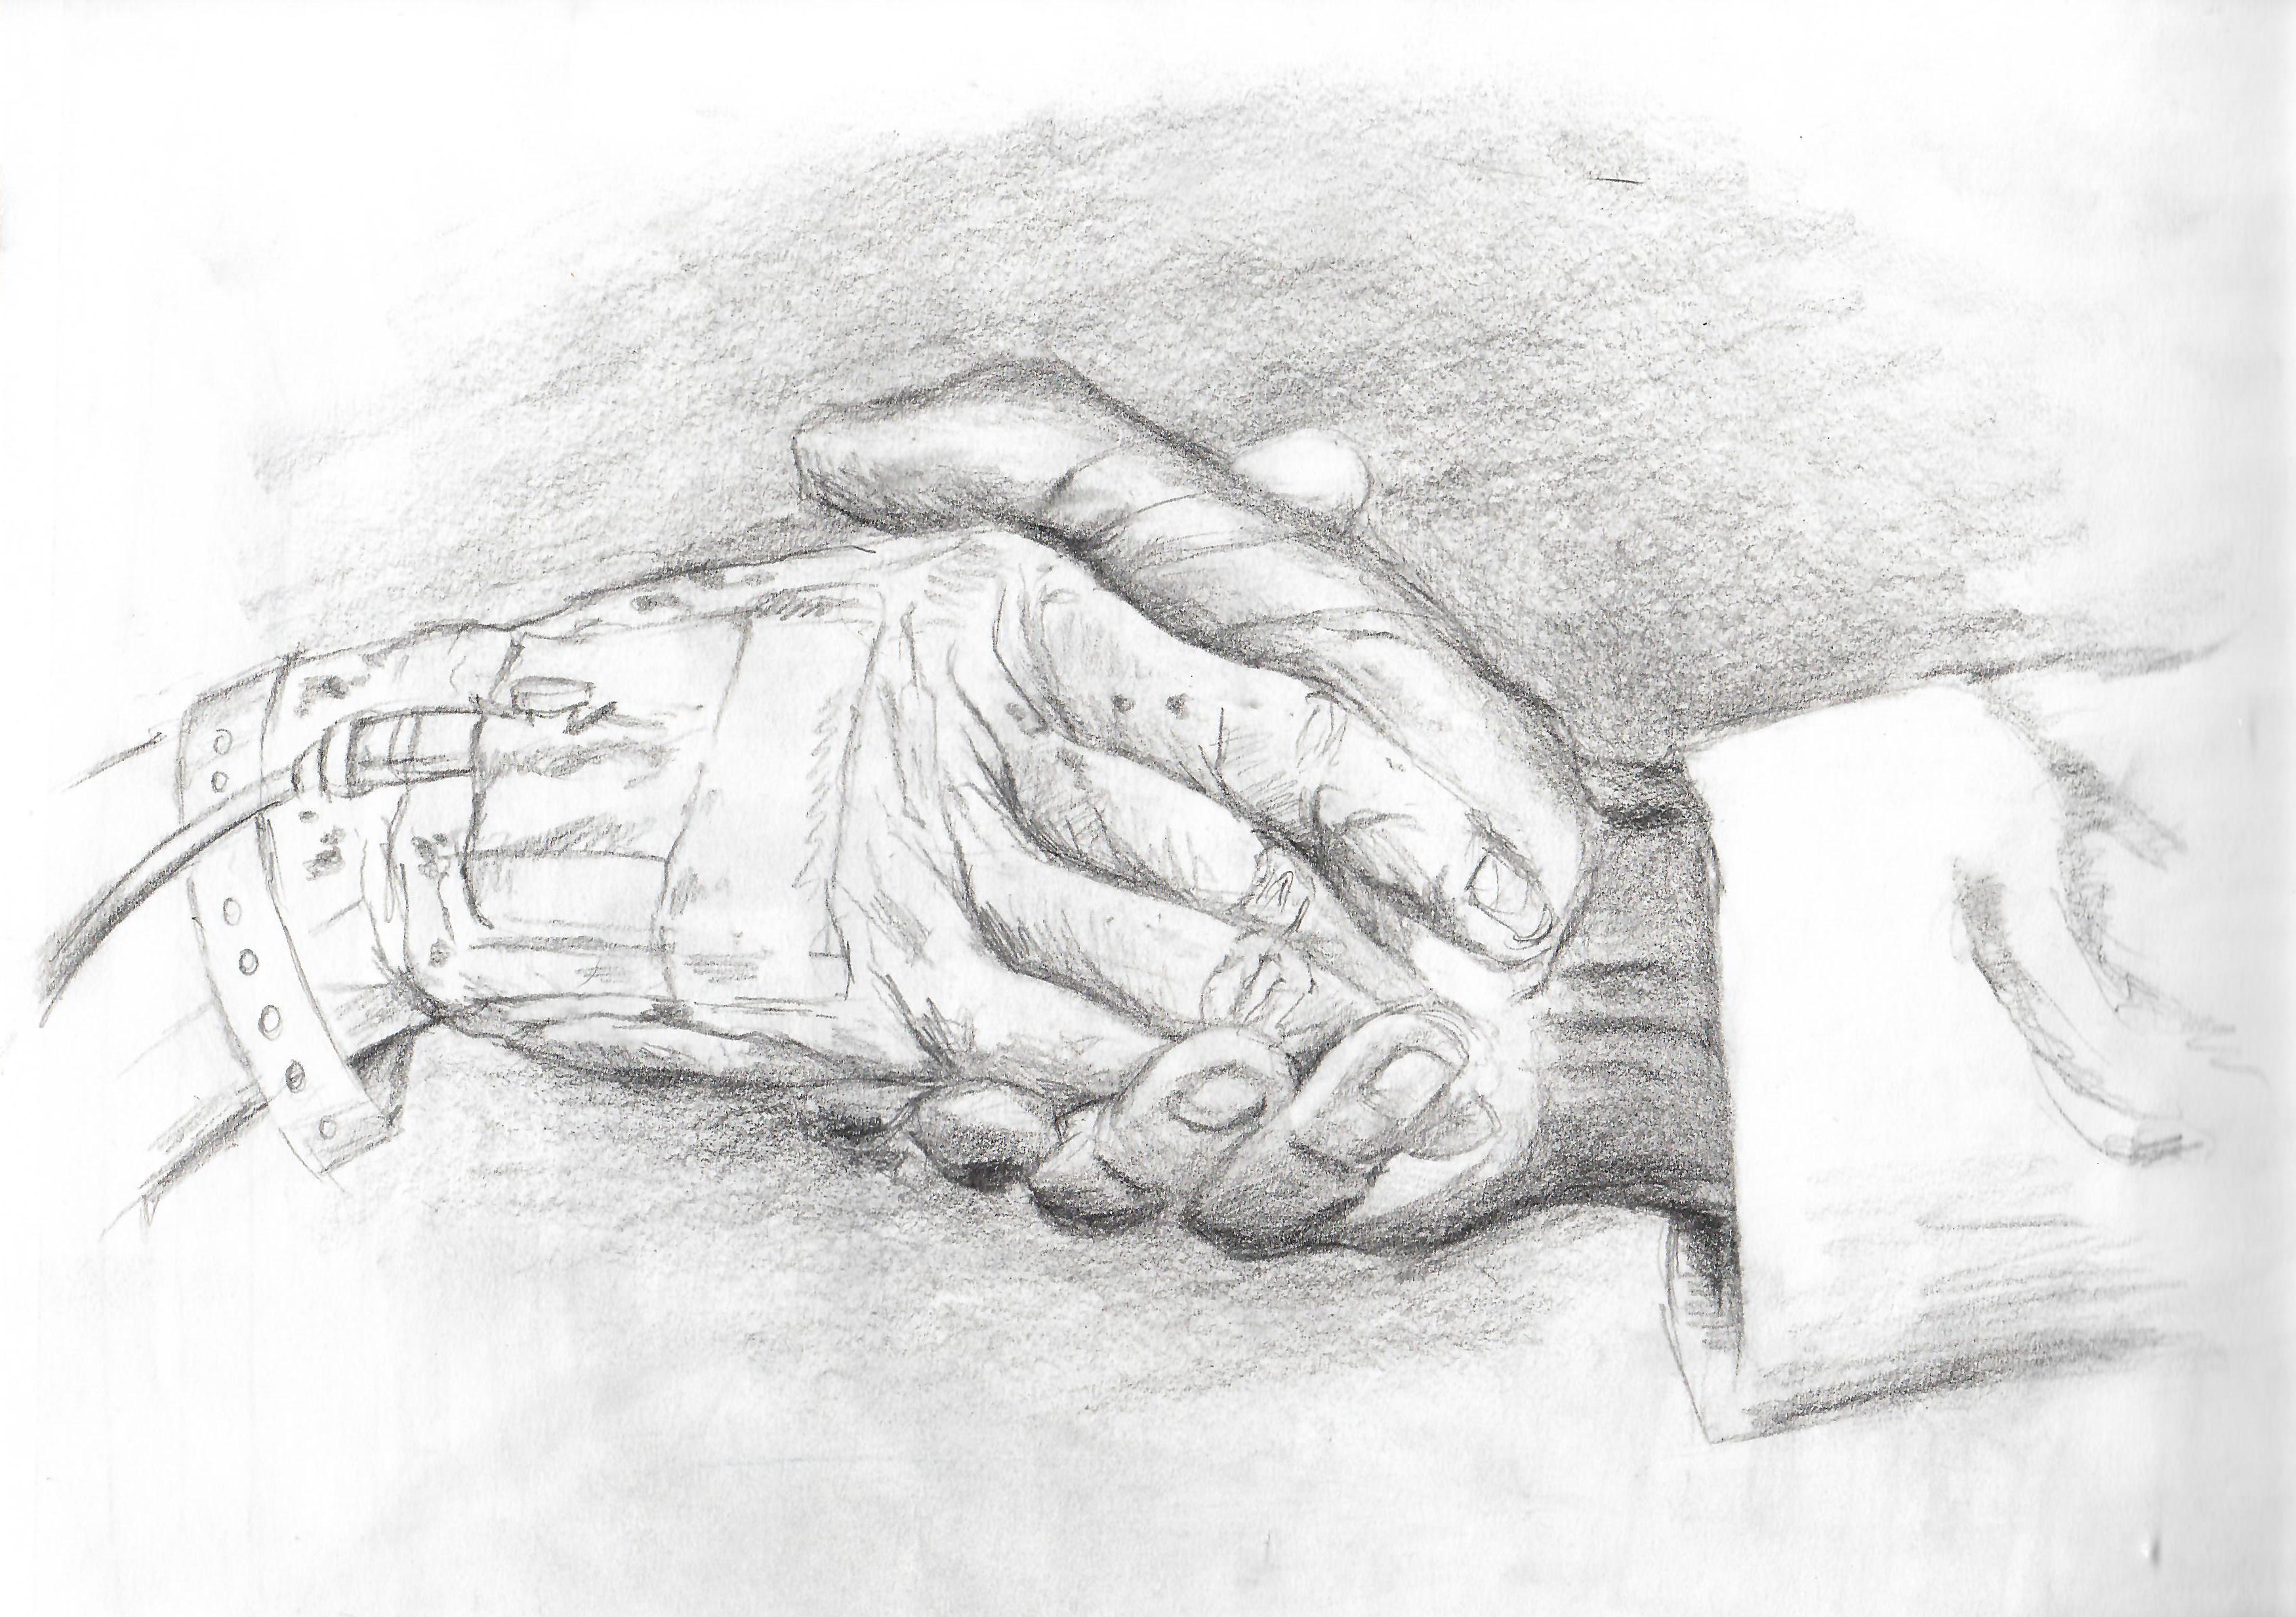
Children know well the power of touch as a tool to both show care and to feel cared for. So too do nurses, CNAs, physical therapists and support staff who daily use touch in their healing. We know that touch alone doesn’t necessarily heal, but a hug, a kiss or a handshake all can help us to feel significantly less alone and better understood. Not only this, but while our culture tells us that pain and suffering are to be avoided, our faith reminds us that it is precisely in experiences of suffering that God rushes in to walk with us, to help us feel understood. Indeed, because of God’s desire to accompany us, moments of pain can, paradoxically, become especially graced. We feel God’s soothing touch. We sigh, smile and carry on with our lives—a little less dramatically this time.

During Holy Week, when we walk with Jesus in his Passion and ultimate death on the Cross, we are offered the chance to enter God’s suffering in the way that God enters ours. Indeed, on Good Friday, we literally kiss the cross as means not only of demonstrating our veneration, but of also indicating that we are with Jesus in his suffering. While we know that our show of care does not change Jesus’ ending, or make the suffering go away, we are reminded that—as ‘God greatly exalted him and bestowed on him the name which is above every other name’—we, too, are strong and will be okay.

How have you felt God’s accompaniment in your own struggles this Lenten season?

How have you borne witness to and accompanied the suffering of God in this season?

