Christ, our paschal lamb, has been sacrificed;
let us then feast with joy in the Lord. 1 Corinthians 5:7b-8a
A young boy and his father were driving down a country road on a beautiful spring afternoon. Out of nowhere a bumblebee flew in the car window. The boy was deathly allergic to bees and so, began to panic. Knowing his allergy, the father quickly reaches out, grabs the bee, squeezes it in his hand and then releases it. Seeing the insect angrily buzzing around the car again, they boy became frantic again.
Seeing his son’s fear, the father reached out his hand saying, “Look here.” There, stuck in his palm was the stinger of the bee. “You see?” he asked. “You don’t need to be afraid anymore. I’ve taken the sting for you.”
I’ve taken the sting for you.
How often have we yearned to say these words to someone in pain? When tragedy strikes our community, we reach out a hand to help. When a friend or family member, loved one or beloved patient, a dear child is afraid, we say to them, I wish I could do something. I wish I could take your place. In the most extreme cases we pray, take me and not them.
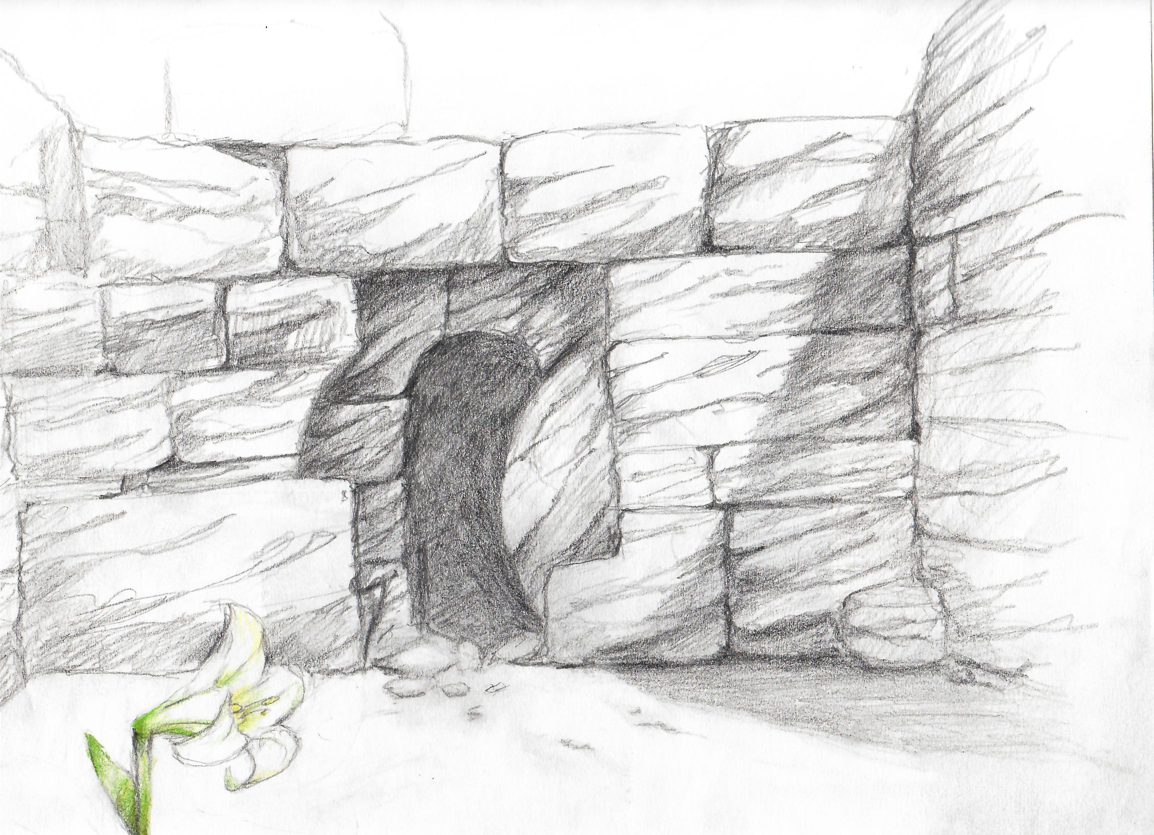
It is the wonder of wonders that our God is the same way. Seeing our isolation from one another, seeing our brokenness and the fear of and power held over us by death, Jesus enters into the death, taking it on himself to remove the sting. The great sin of Eden was not so much about a fruit tree as it was about the rejection of our oneness with God, the forgetting that we are beloved of God and belong to one another.
Lent is the journey back to these two truths and they are what we celebrate this Easter. No matter what, we are beloved of God – not even death can separate us, and in spite of all that may point to the contrary, we belong to one another. Our call in Catholic health care is to witness daily to God’s promise of life over death and joy over suffering. Our role in Catholic health care is to heal in such a way that lives are transformed and communities are rebuilt. As the people of Catholic health care, we witness to these Easter truths every day.
Where we had been broken, Christ mends us. Where we had been scattered, Christ binds us together. Where we had fallen, Christ lifts us up again. Where we had been dead, Christ brings new life. And we proclaim with Saint Paul,
Listen, I will tell you a mystery! We will not all die, but we will all be changed, in a moment, in the twinkling of an eye, at the last trumpet. When this perishable body puts on imperishability, and this mortal body puts on immortality, then the saying that is written will be fulfilled:
“Death has been swallowed up in victory.”
“Where, O death, is your victory?
Where, O death, is your sting?”
1 Corinthians 15:51, 53-55

